**COIMBATORE INSTITUTE OF TECHNOLOGY**

**(Government-Aided Autonomous Institution)**

**Coimbatore – 641014**



**Department of Computing**

**19MAM65 – Deep Learning Lab**

**Record Work**

**Submitted by**

JYOTSHSNA S

2034023

**Submitted to**

Dr. J.Shana

Dr.D.Kavitha

**INDEX**

|  |  |  |
| --- | --- | --- |
| **Ex No** | **Title** | **Date** |
| 01 | SIMPLE ARTIFICIAL NEURAL NETWORK | 02/01/2023 |
| 02 | ANN GENDER CLASSIFICATION | 02/01/2023 |
| 03 | CNN GENDER CLASSIFICATION | 09/01/2023 |
| 04 | REGULARIZATION IN CNN | 09/01/2023 |
| 05 | AUGMENTATION TECHNIQUE | 27/01/2023 |
| 06 | SIMPLE RNN | 27/01/2023 |
| 07 | CATS AND DOGS AUDIO CLASSIFICATION USING CNN | 03/02/2023 |
| 08 | RNN FOR STOCK PRICE PREDICTION | 03/02/2023 |
| 09 | NEXT WORD PREDICTION – RNN | 13/02/2023 |
| 10 | NEXT WORD PREDICTION USING LSTM | 13/02/2023 |
| 11 | CNN FOR HANDWRITTEN DATA [MNIST] | 03/03/2023 |
| 12 | LSTM FOR IMDB DATASET | 03/ 03/2023 |
| 13 | TRANSFER LEARNING,FEATURE EXTRACTION AND FINE TUNING OF VGG-16 | 06/ 03/2023 |
| 14 | BERT MODEL FOR IMDB DATASET | 10/04/2023 |
| 15 | GANS FOR MNIST DATASET | 17/04/2023 |
| 16 | PROJECT- CUSTOM QUESTION ANSWERING | 17/04/2023 |

EX NO:1 SIMPLE ARTIFICIAL NEURAL NETWORK

DATE: 02.01.23

AIM:

To implement 3 layered ANN architecture using fashion MNIST dataset.

CODE:

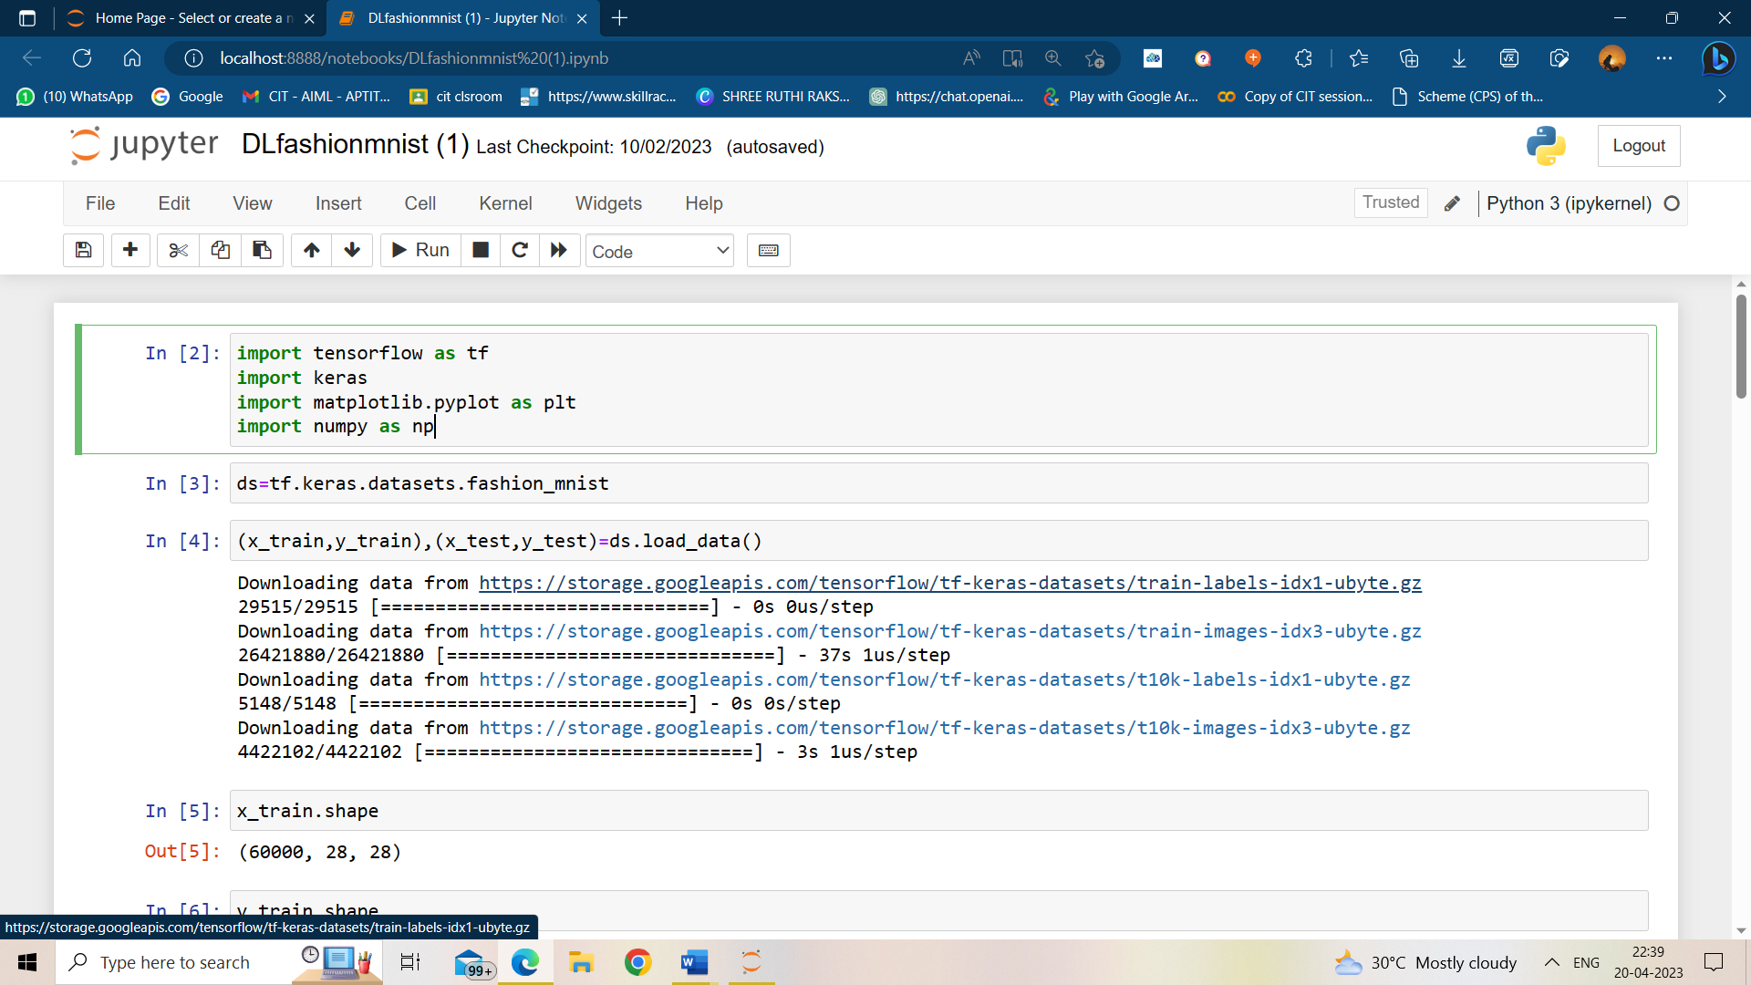

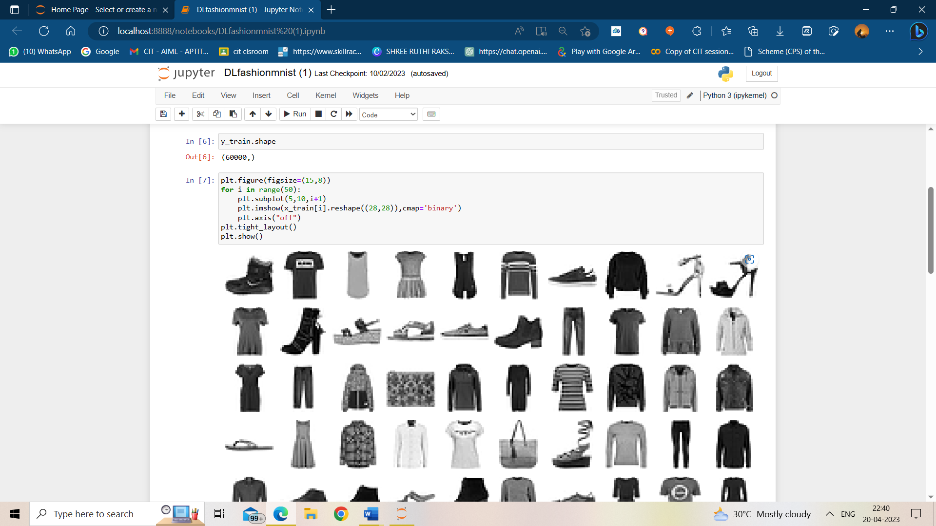

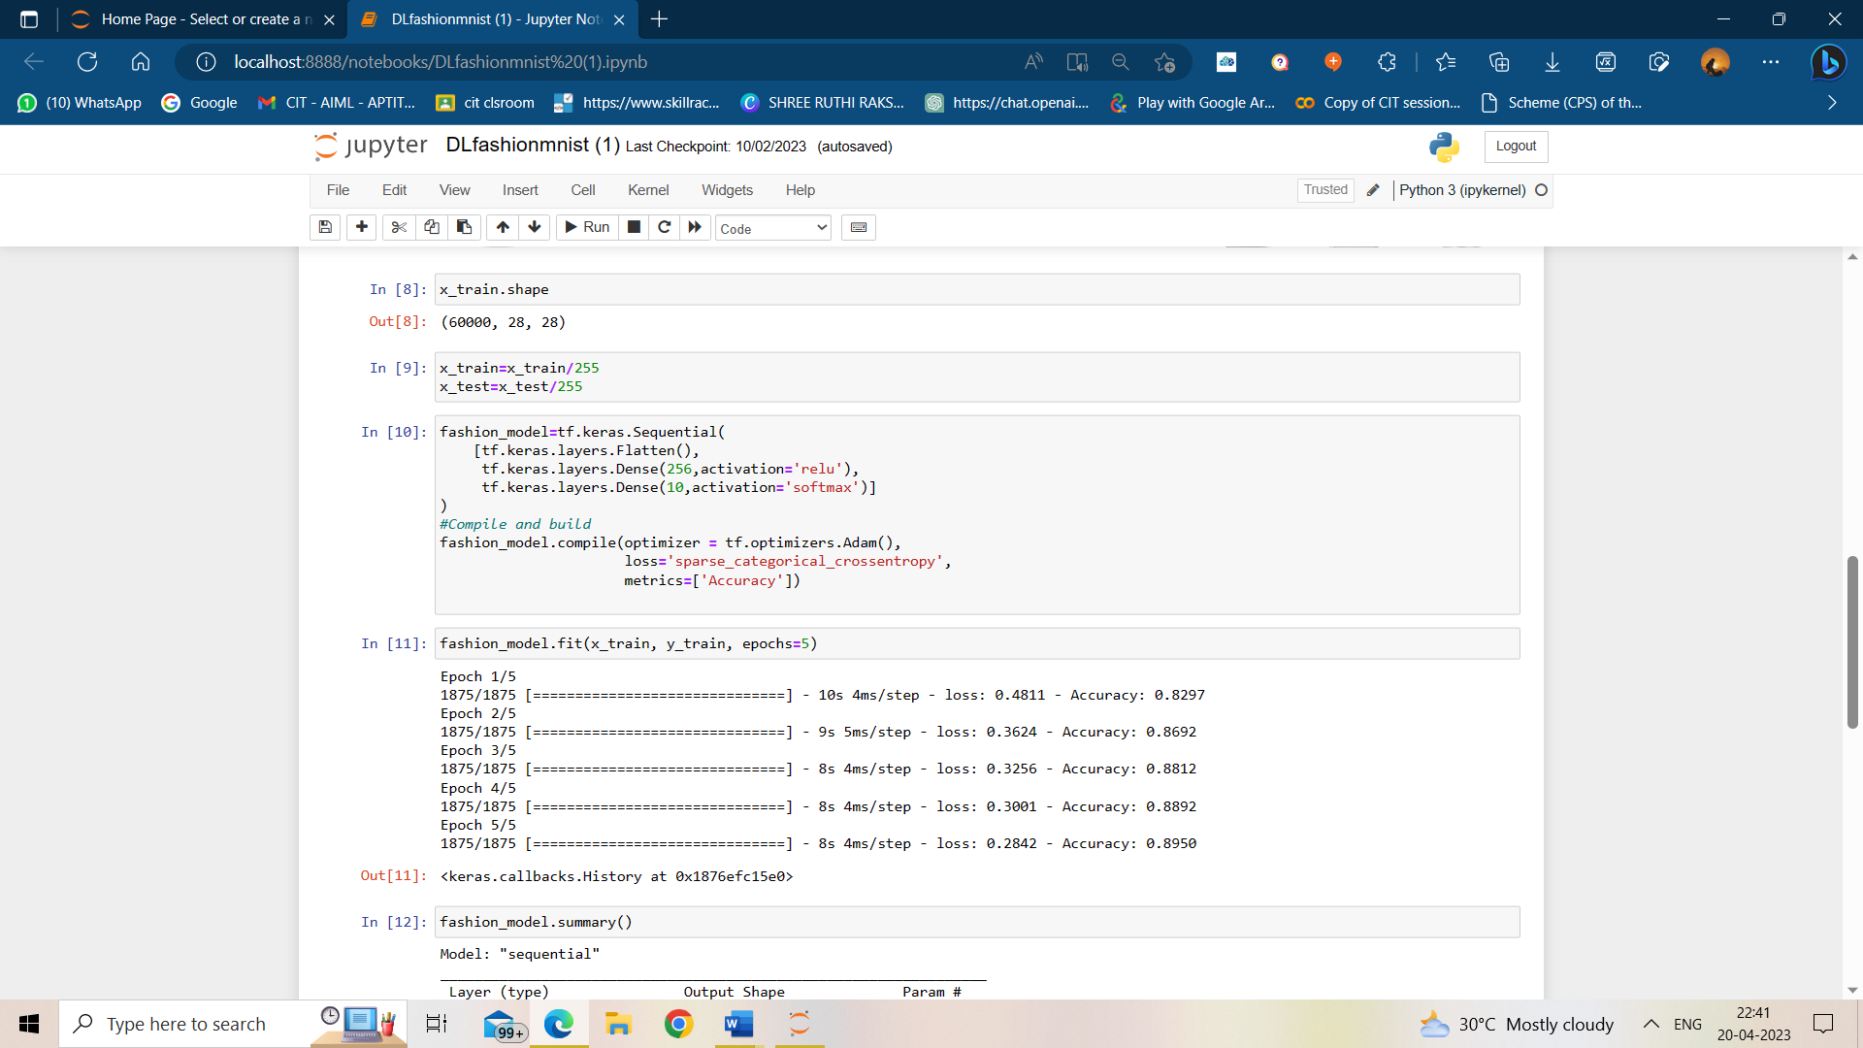

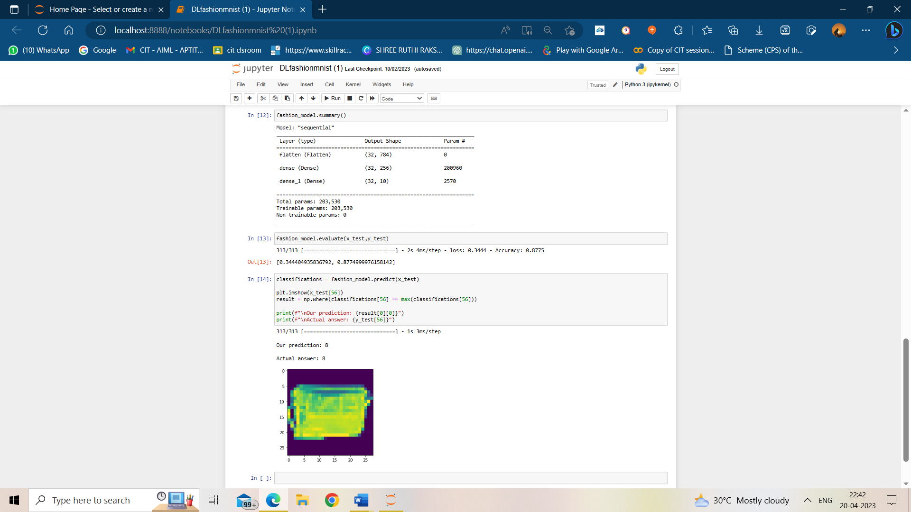

EX NO:2 ANN GENDER CLASSIFICATION

DATE:02.01.23

AIM:

To implement ANN and classify gender.

CODE:

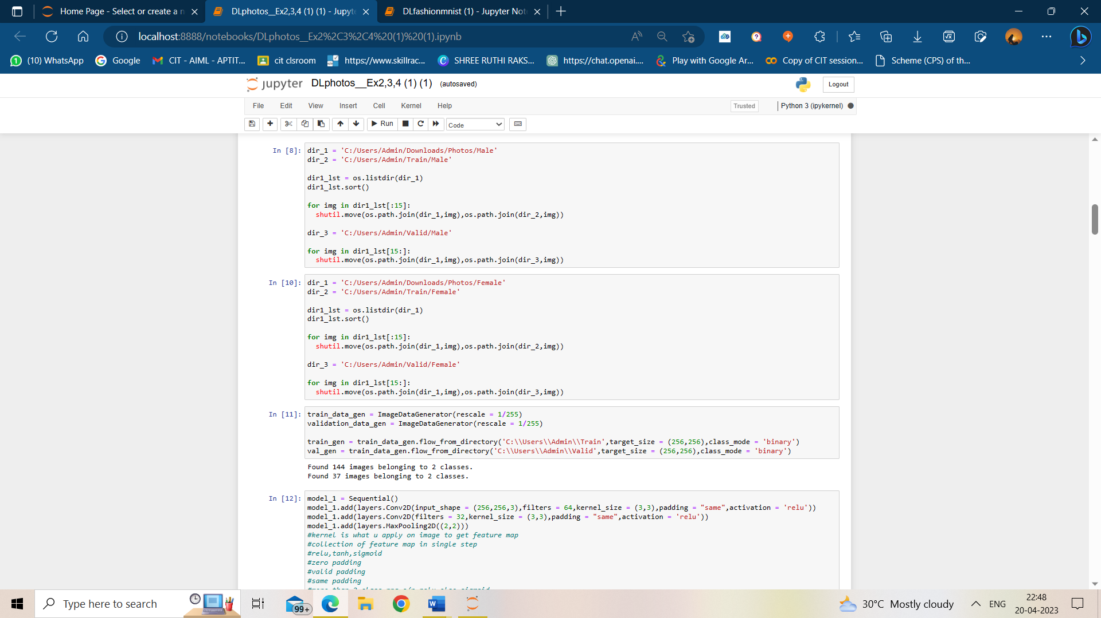

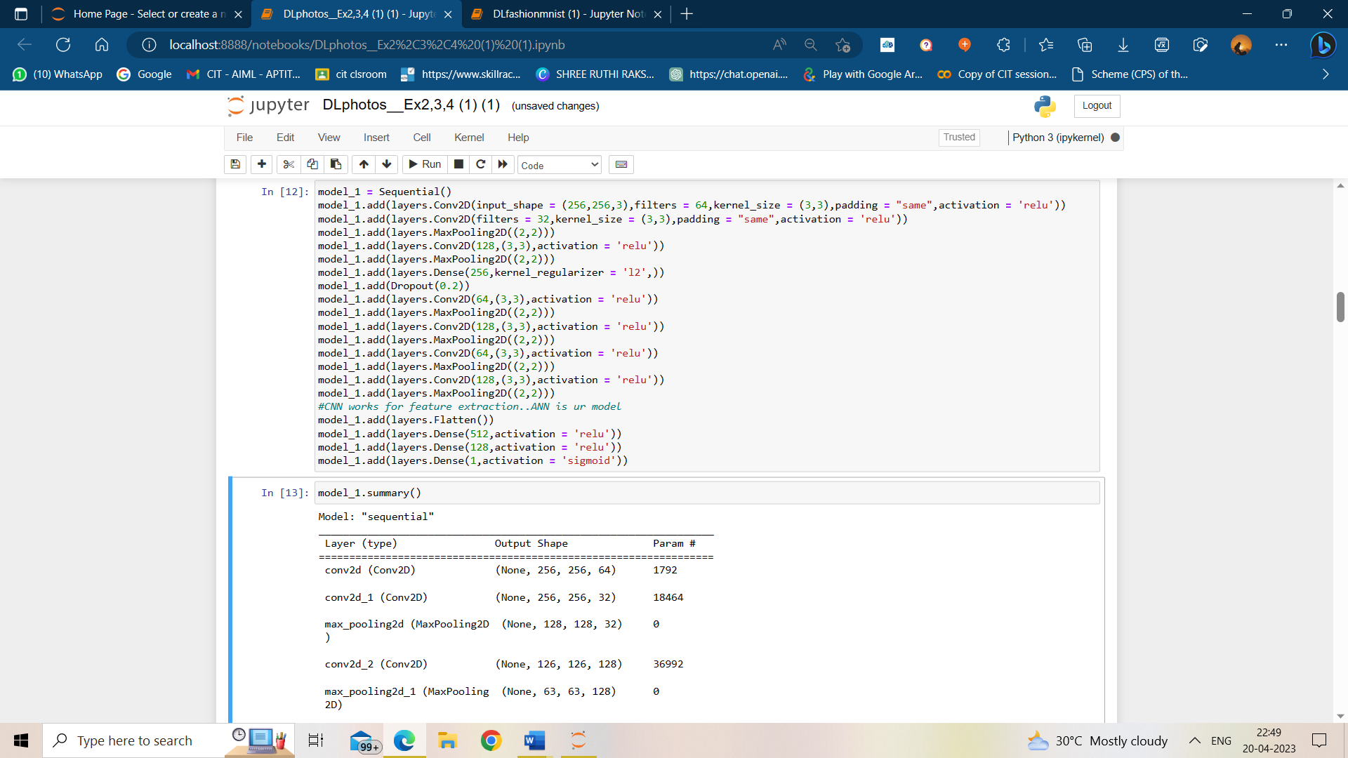

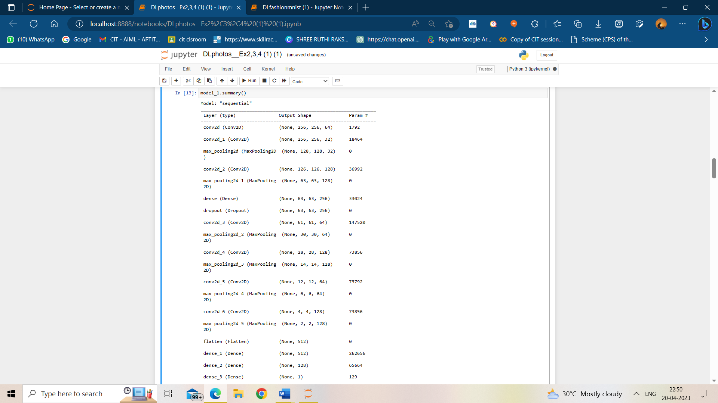

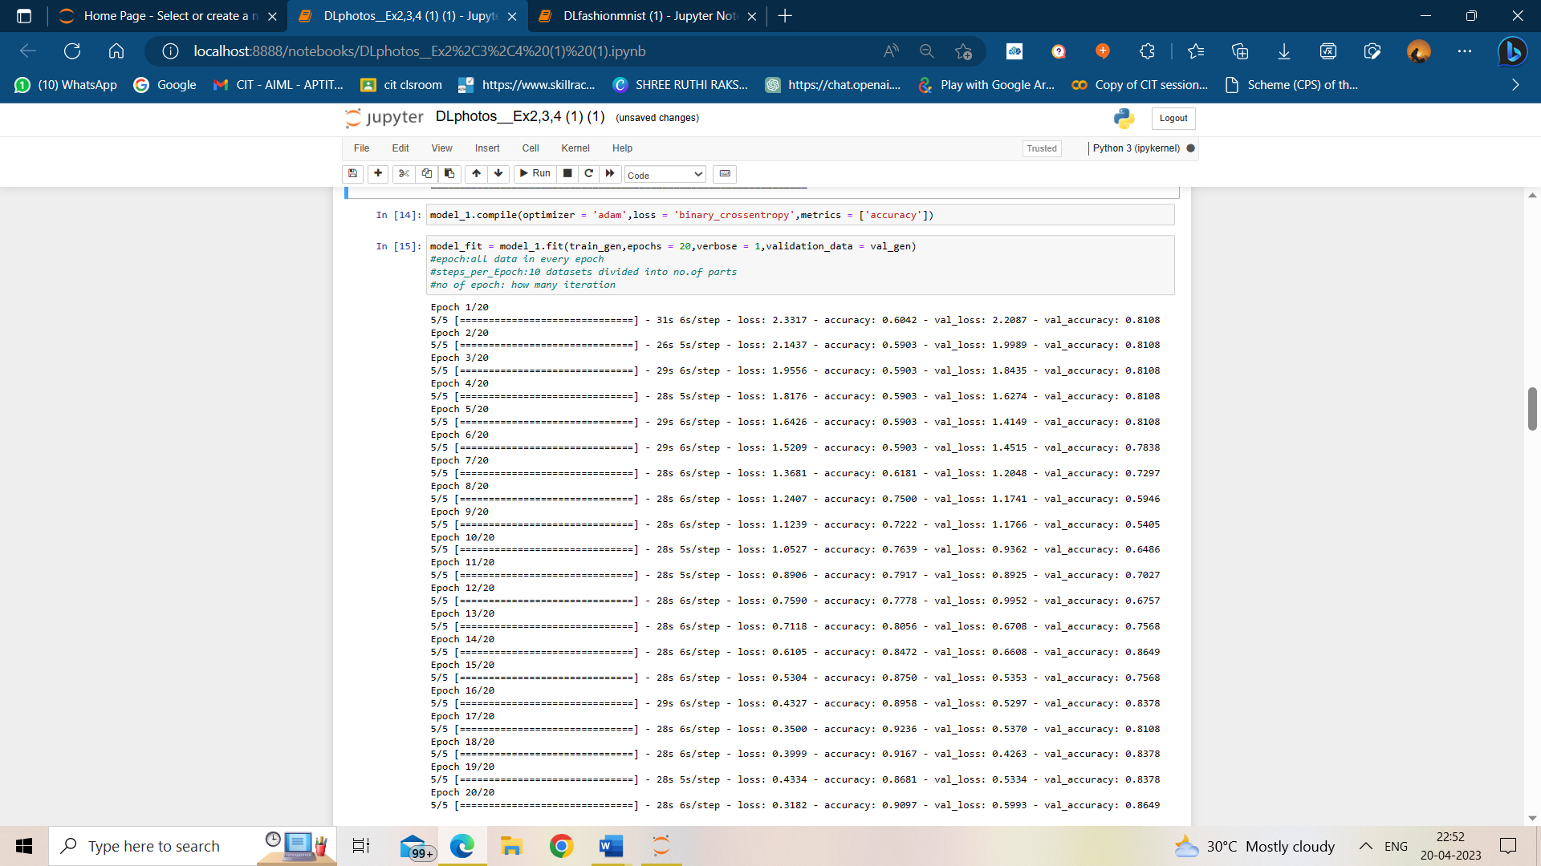

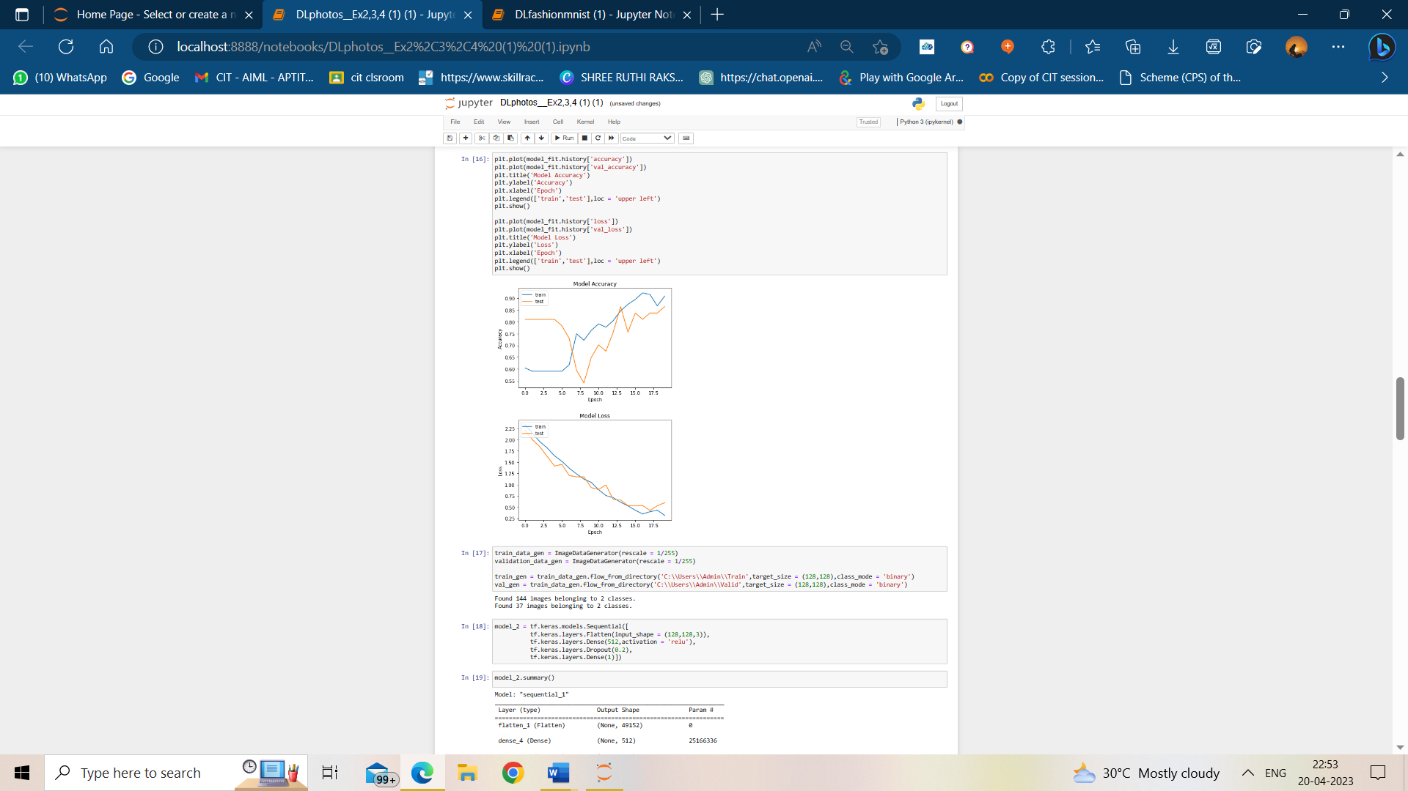

EX NO:3 CNN GENDER CLASSIFICATION

DATE: 09.01.23

AIM:

To perform classification of male and female using a basic CNN model.

CODE:

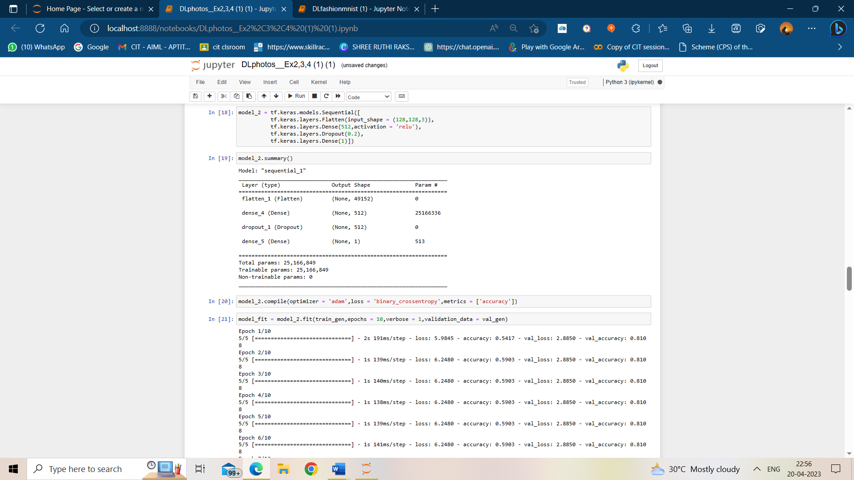

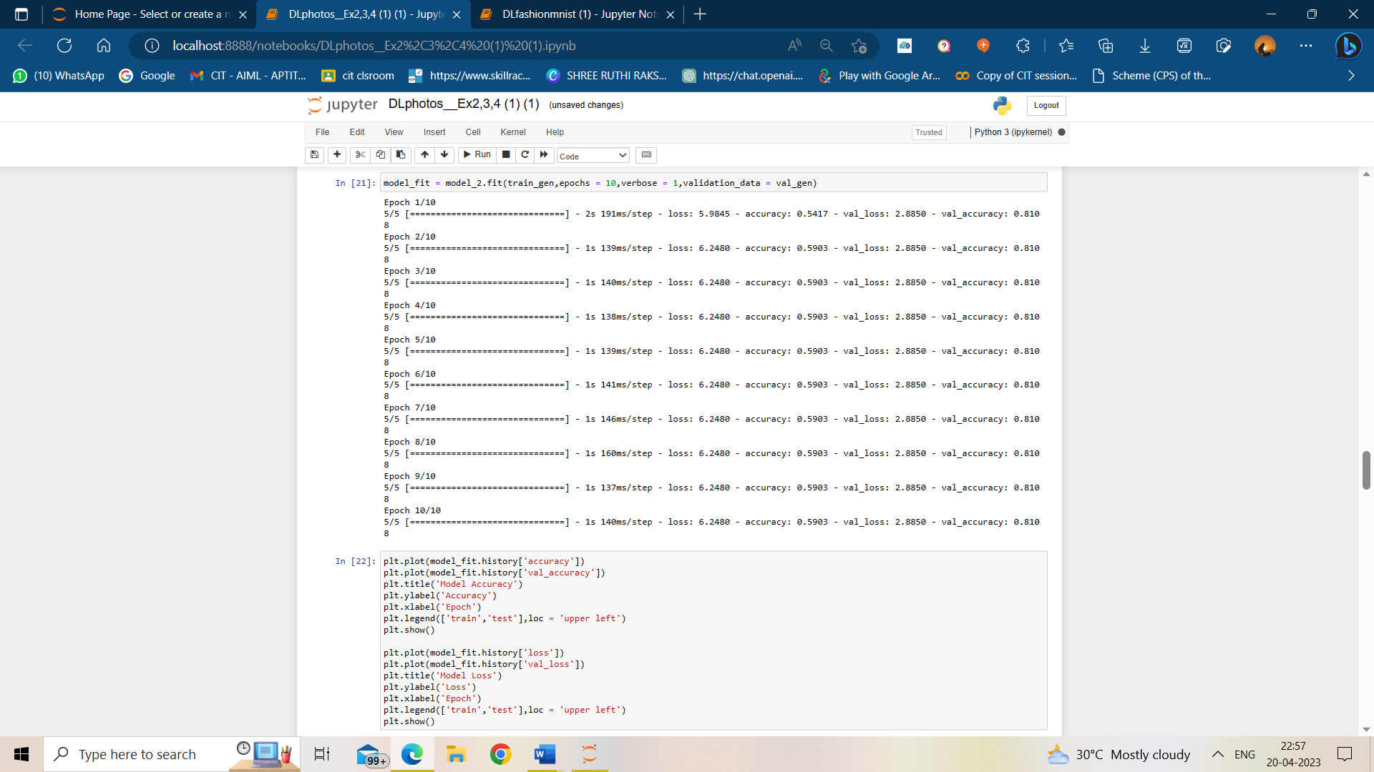

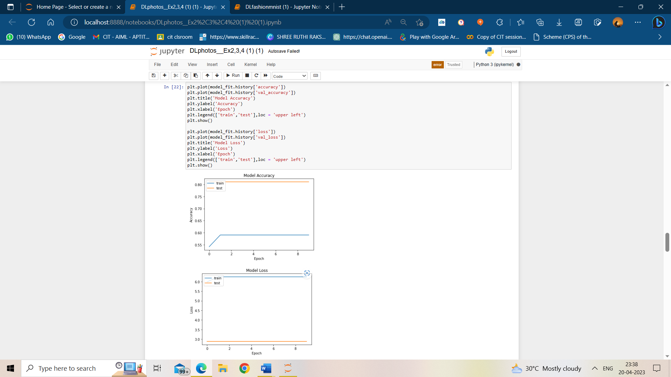

EX NO:4 REGULARIZATION IN CNN

DATE:12.02.23

AIM:

To use the regularization technique in the CNN model and record the results.

CODE:

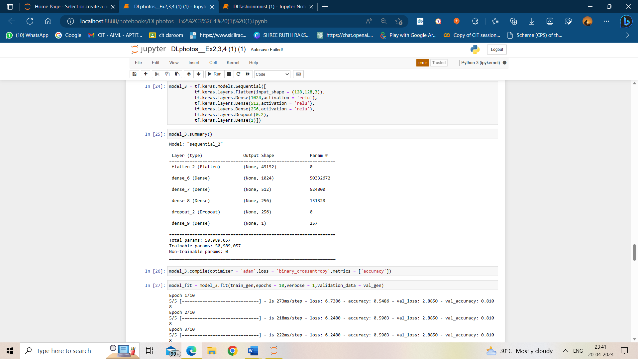

`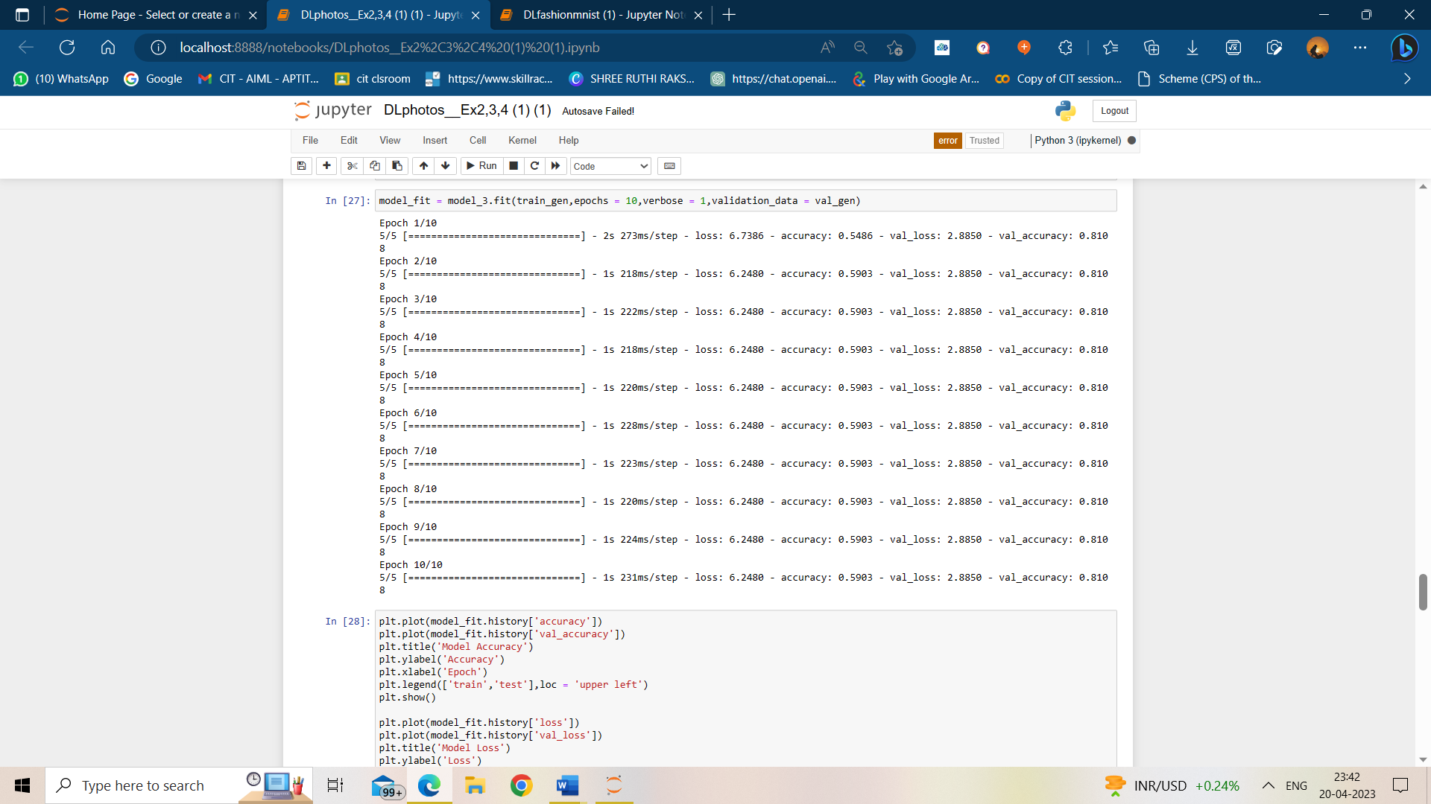

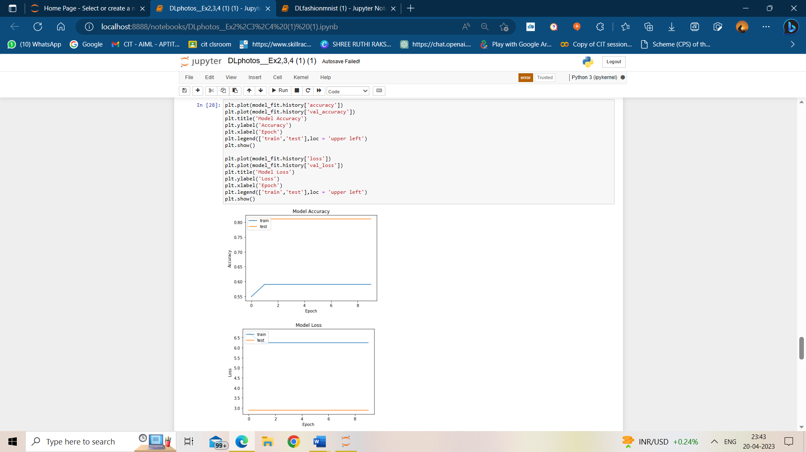

EX NO:5 AUGMENTATION TECHNIQUE

DATE:27.01.23

AIM:

To use augmentation technique in a CNN to predict the gender of the image.

CODE:

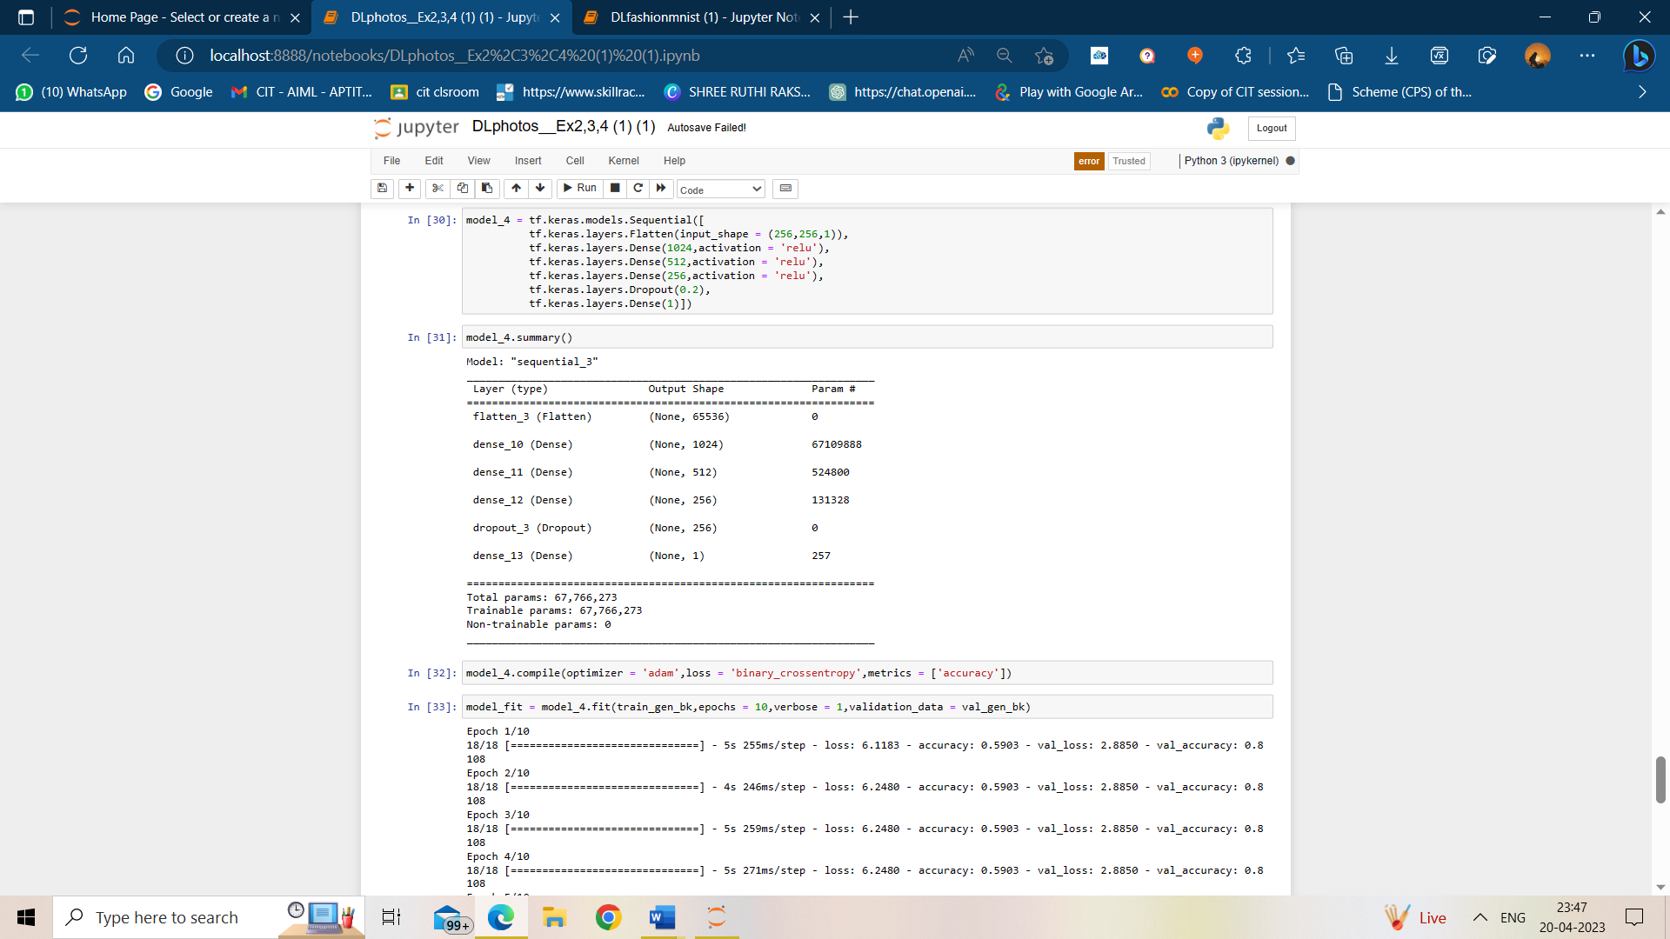

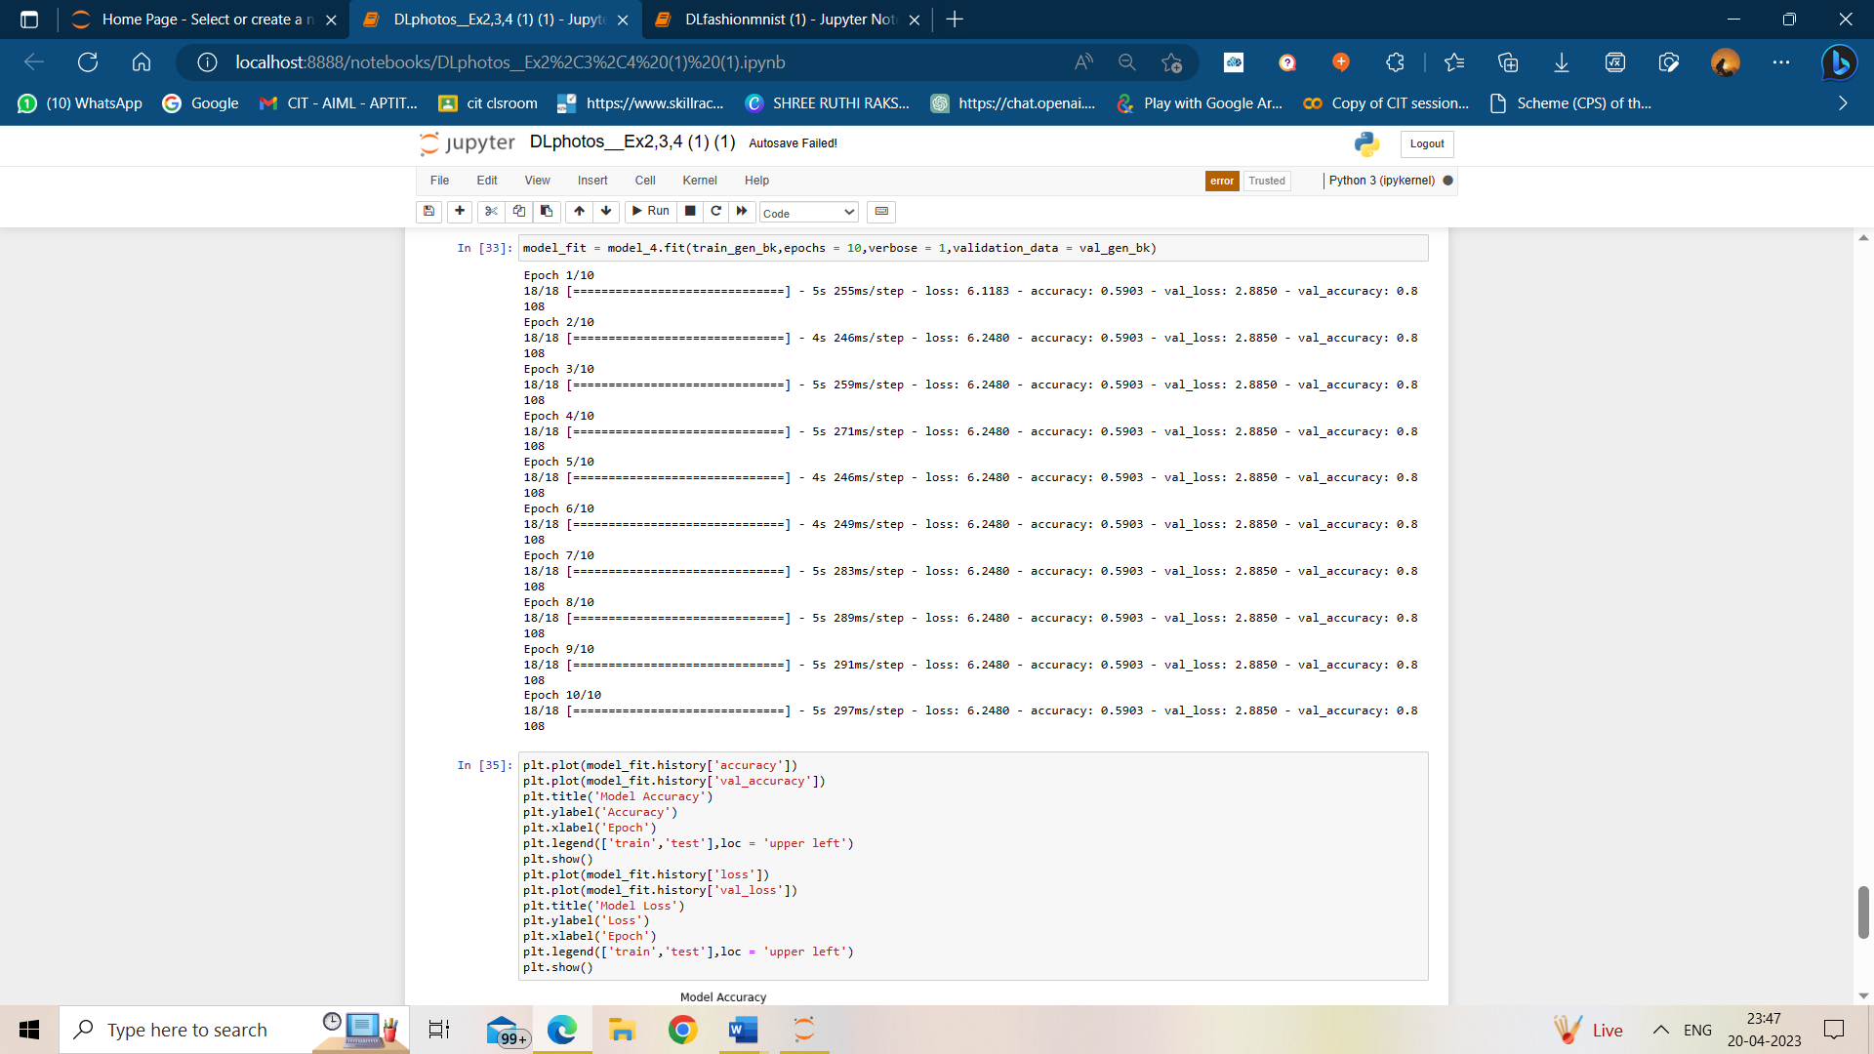

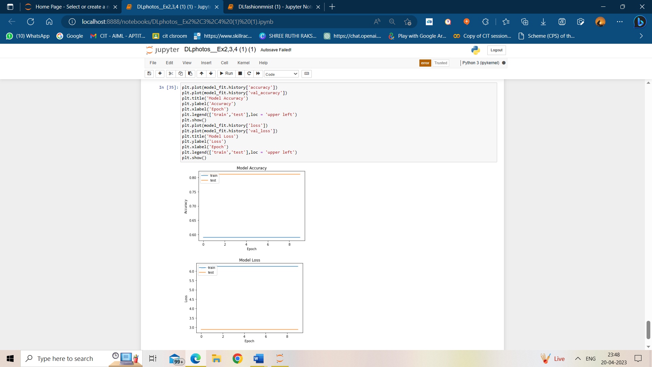

EX.NO:06 SIMPLE RNN

DATE:27.01.23

AIM:

To implement a simple RNN architecture for a self-created time series data set and predict based on it.

CODE:

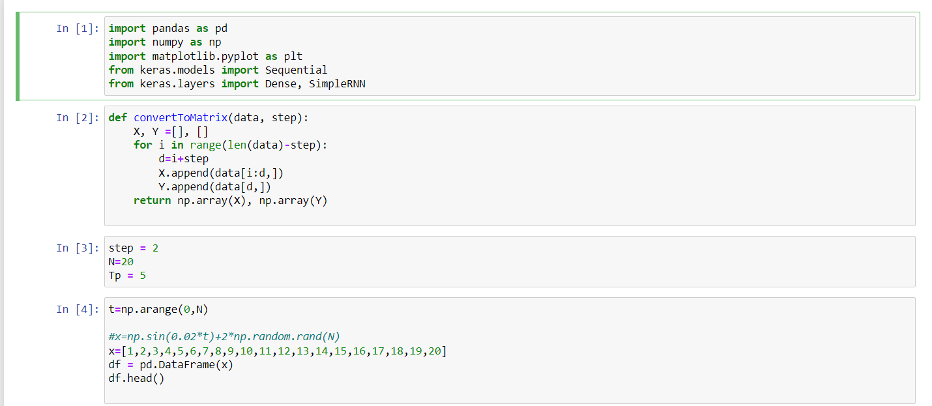 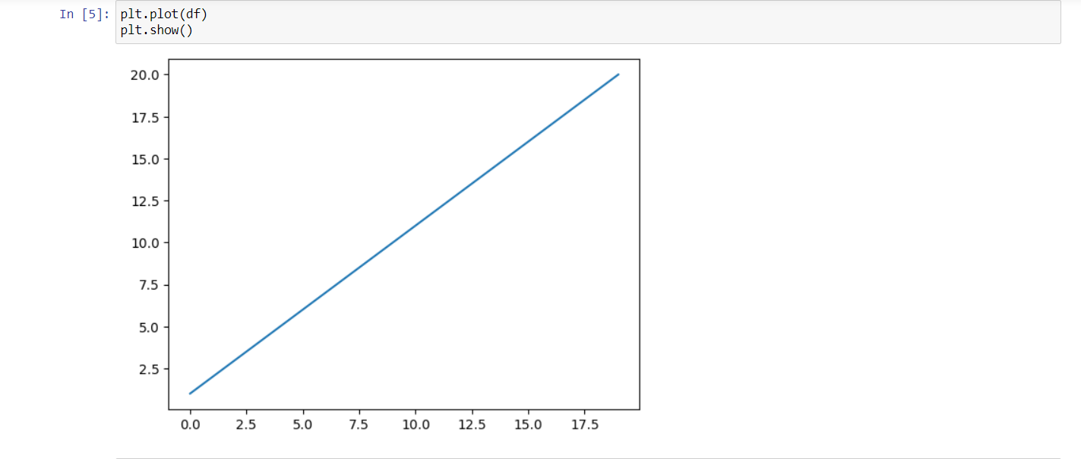

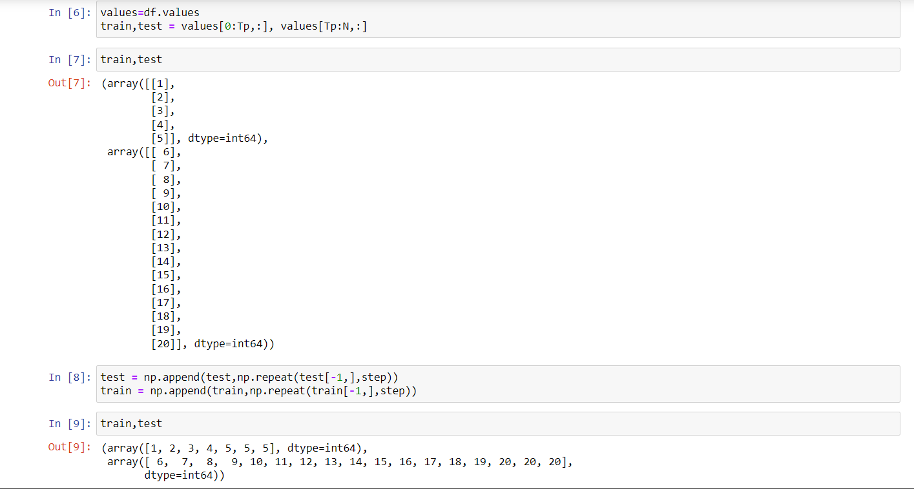

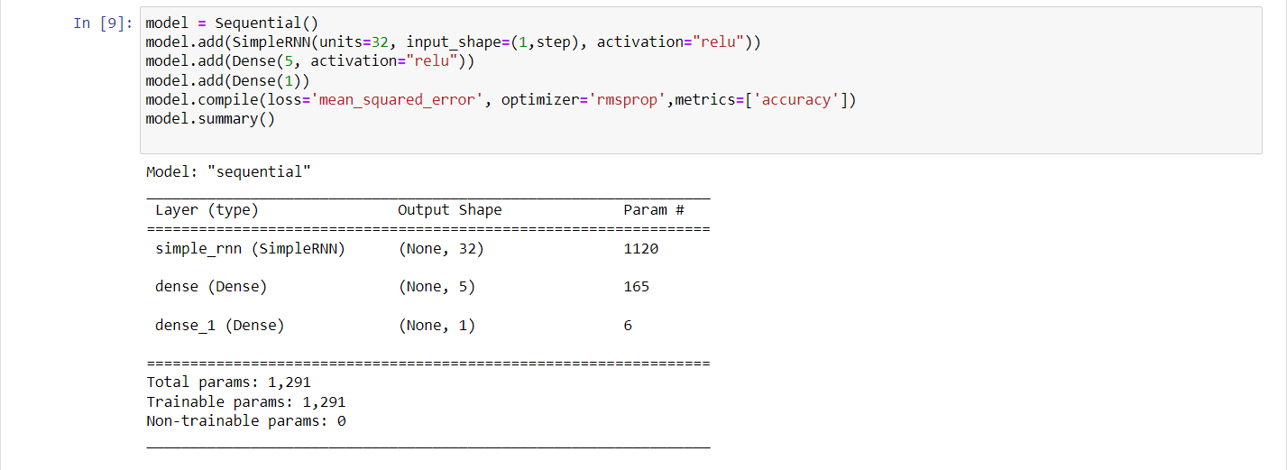

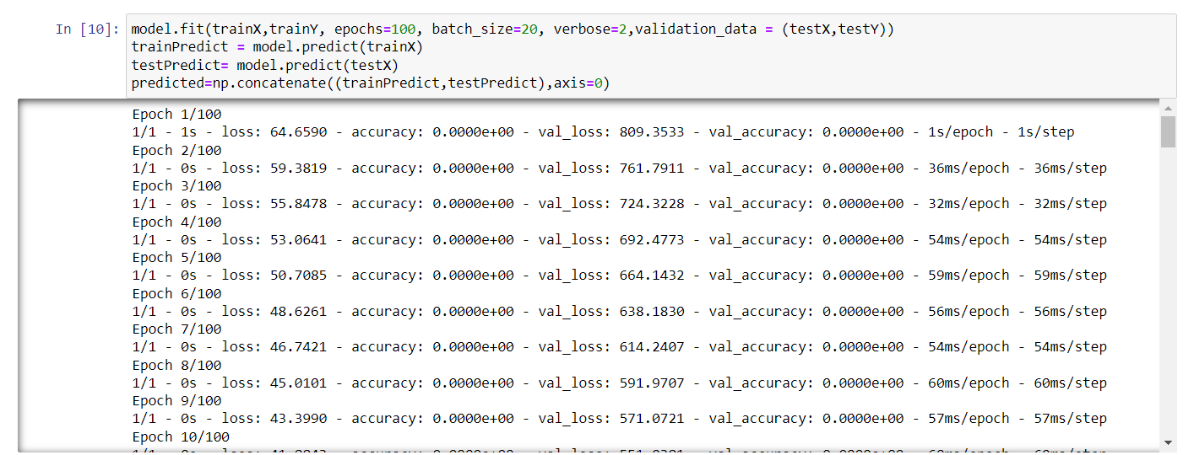

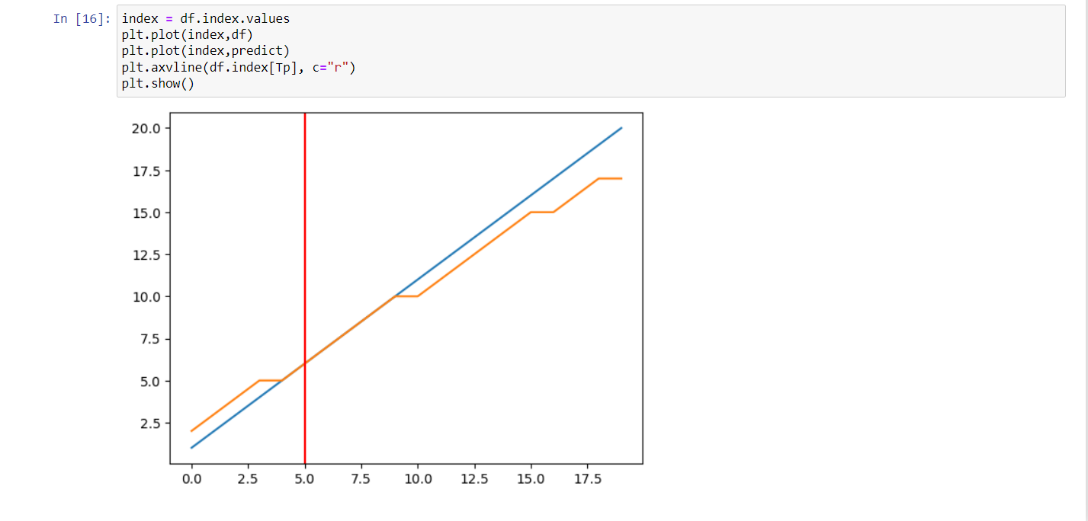

EX.NO:07 CATS AND DOGS AUDIO CLASSIFICATION USING CNN

DATA: 03.02.23

AIM:

To implement a CNN for an audio dataset and classify whether it is cat or dog.

CODE:

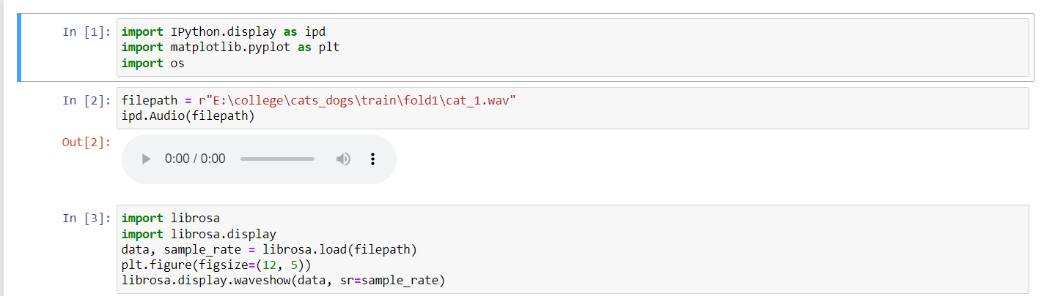

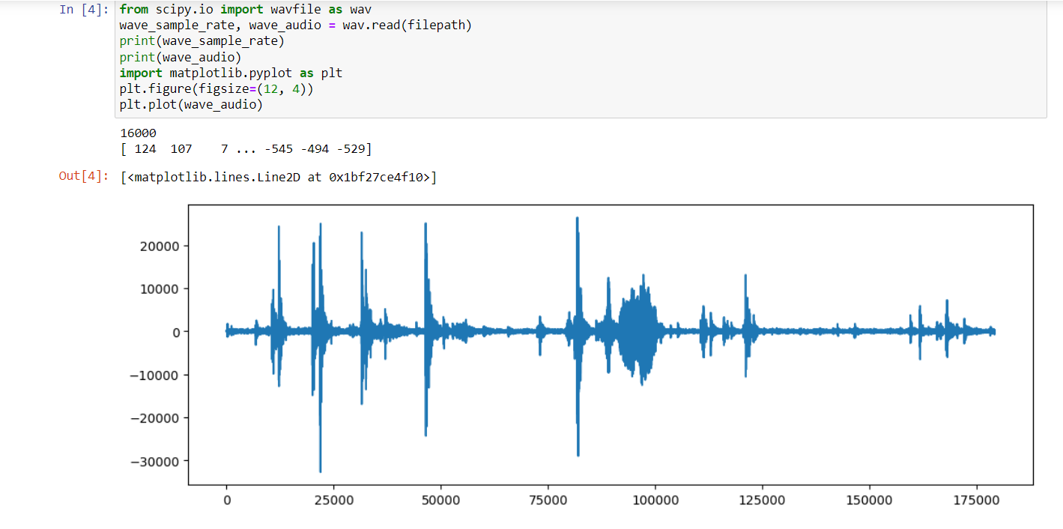 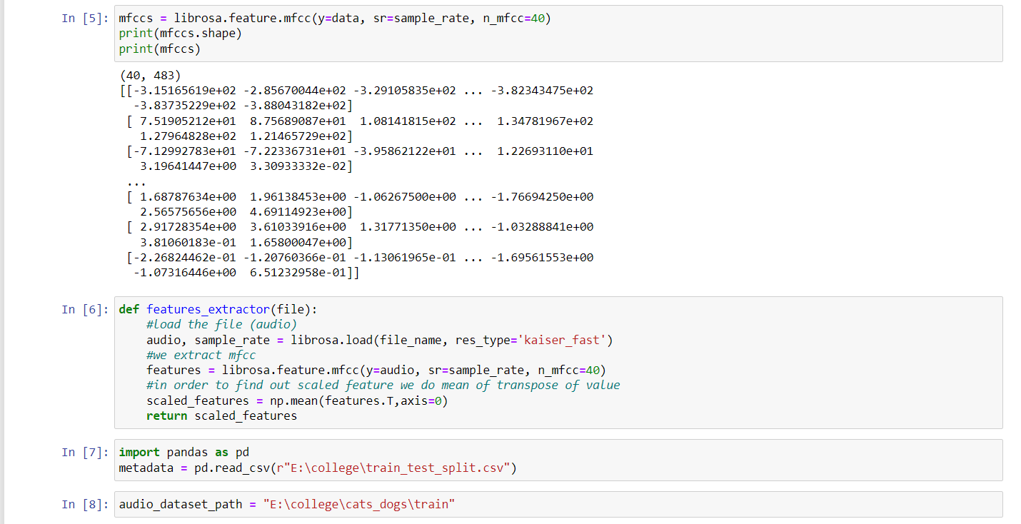

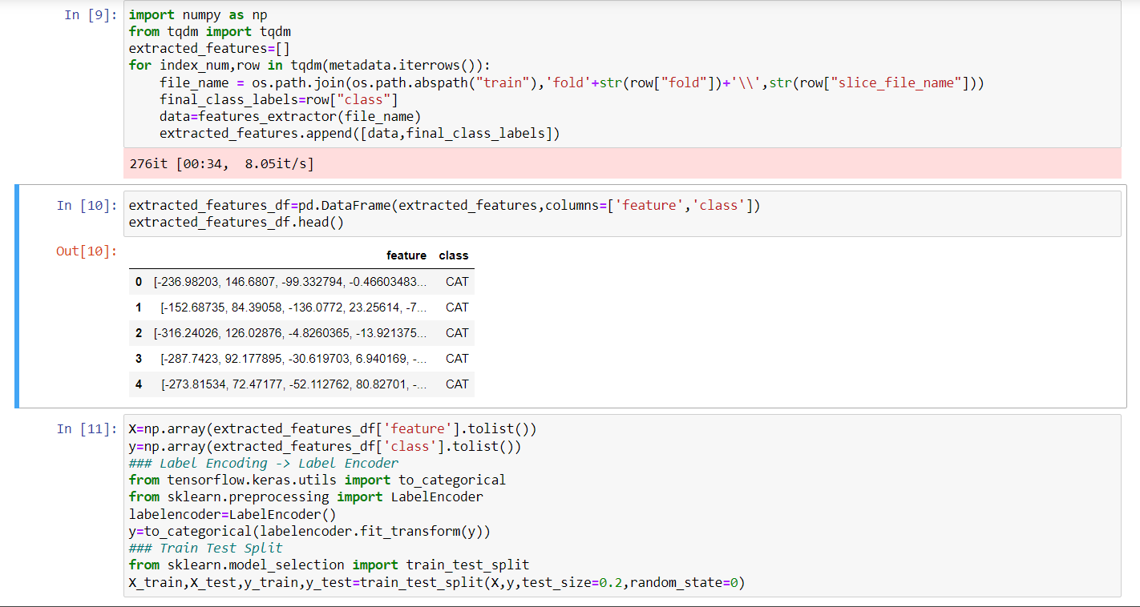 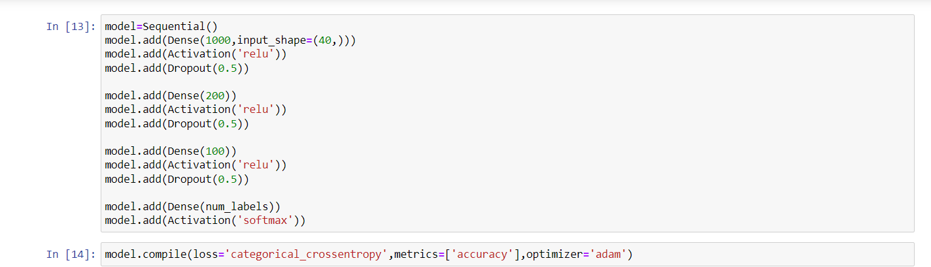 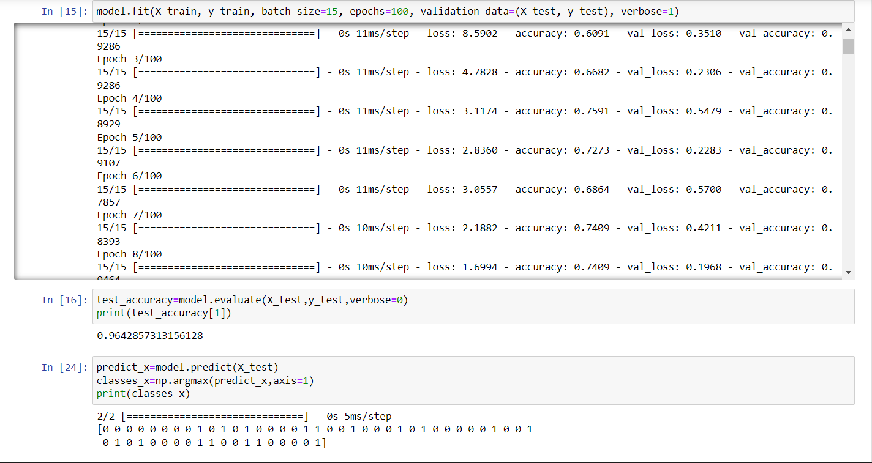

EX.NO:08 RNN FOR STOCK PRICE PREDICTION

DATE:03.02.23

AIM:

To implement an RNN to predict the stock price for the tesla stock price dataset.

CODE: 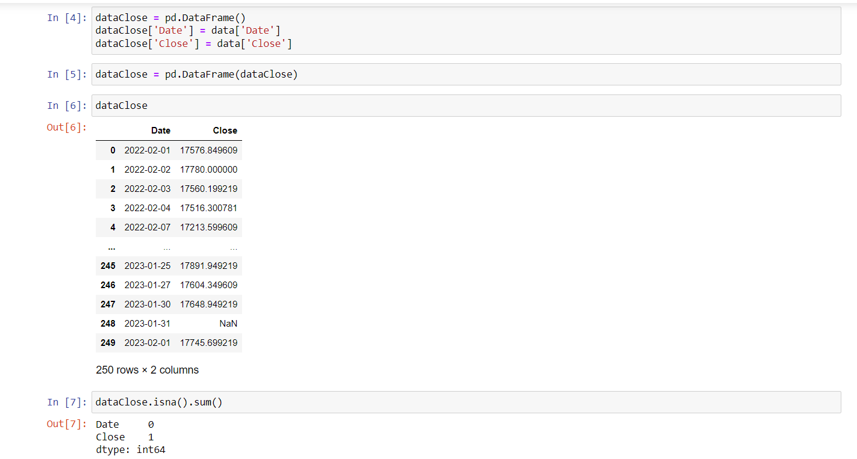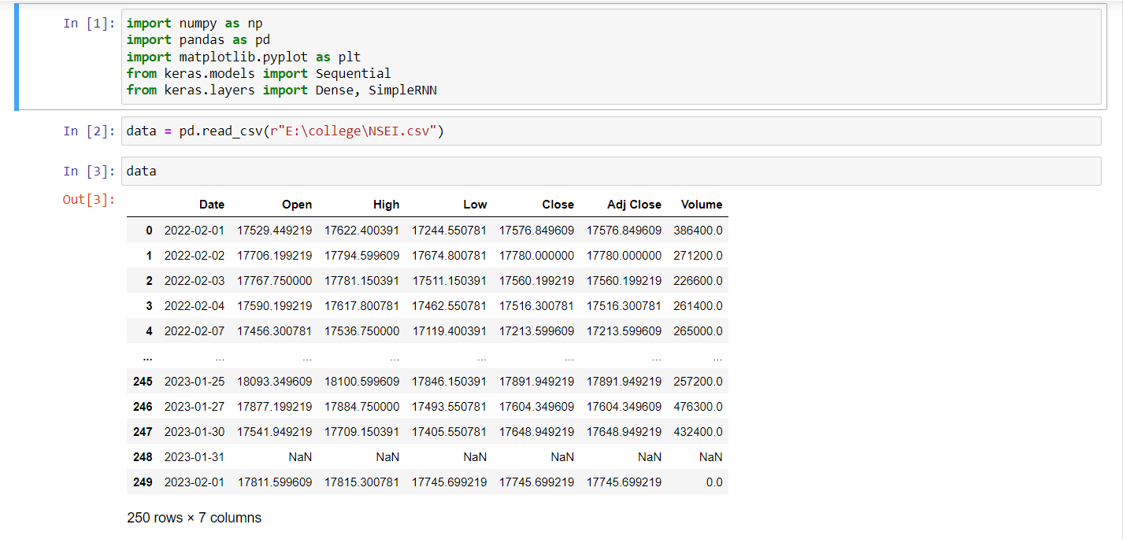

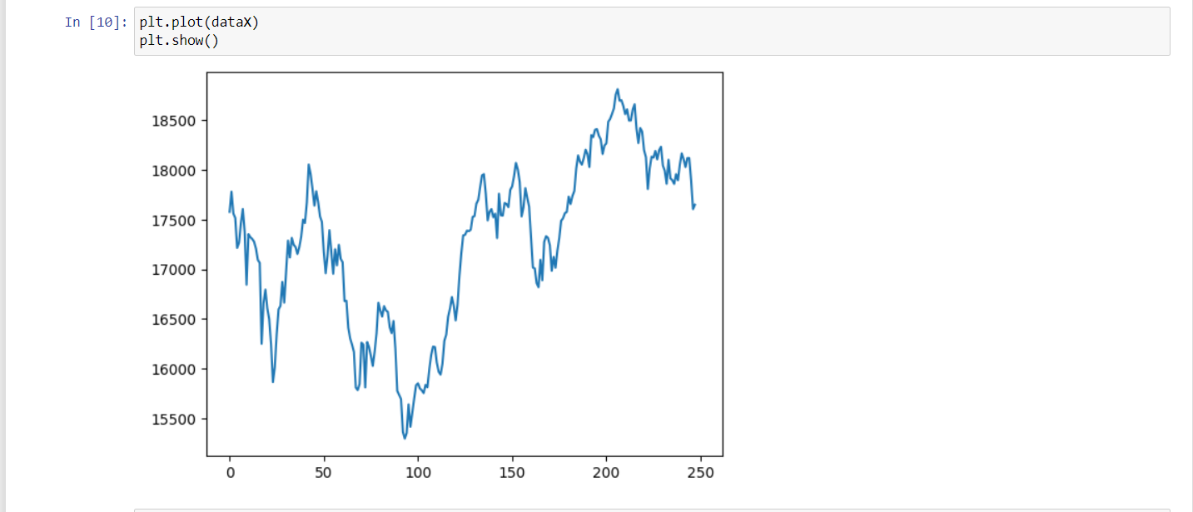 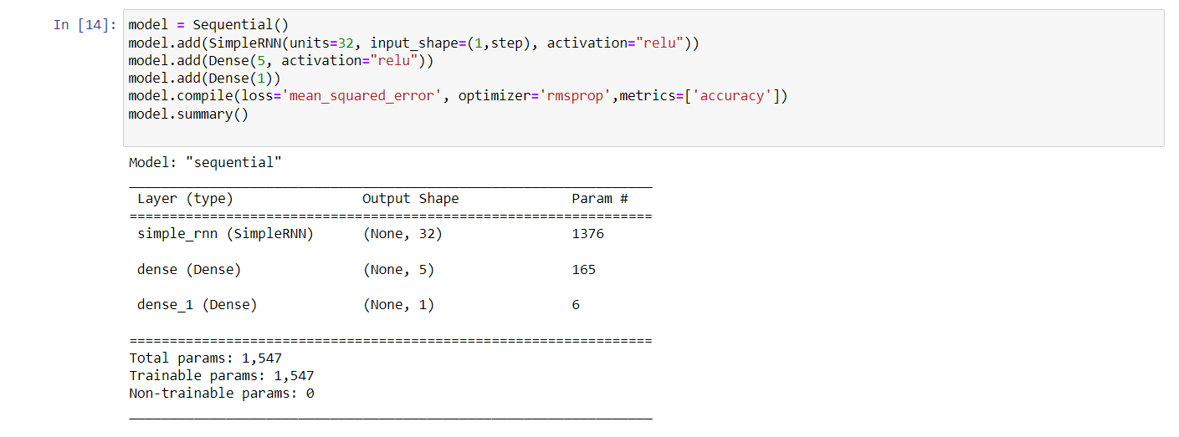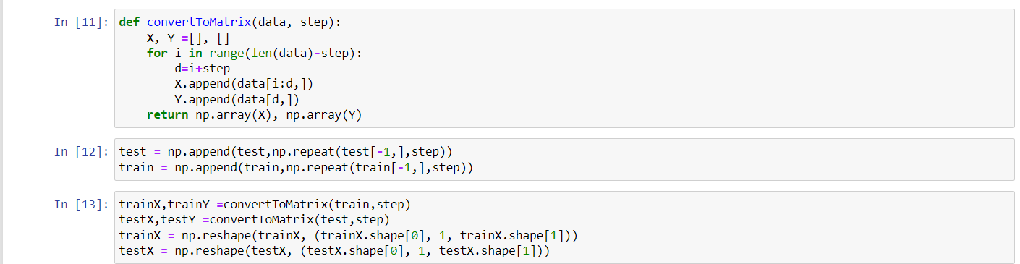 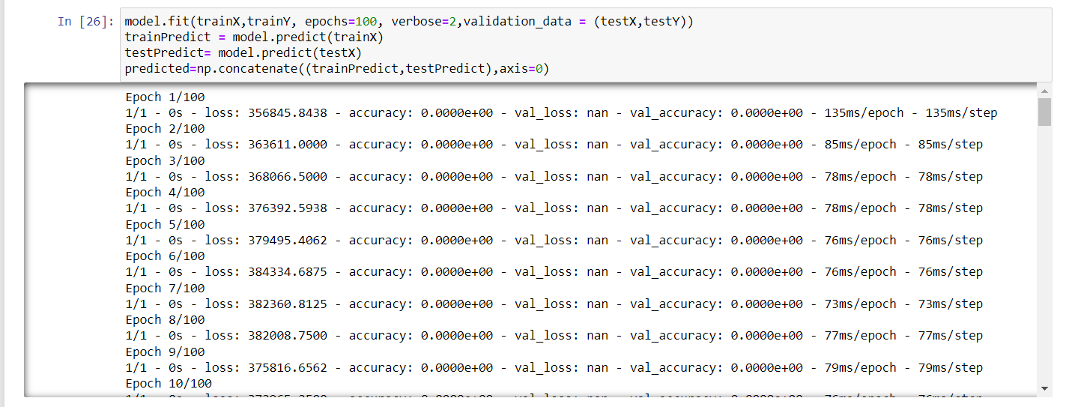

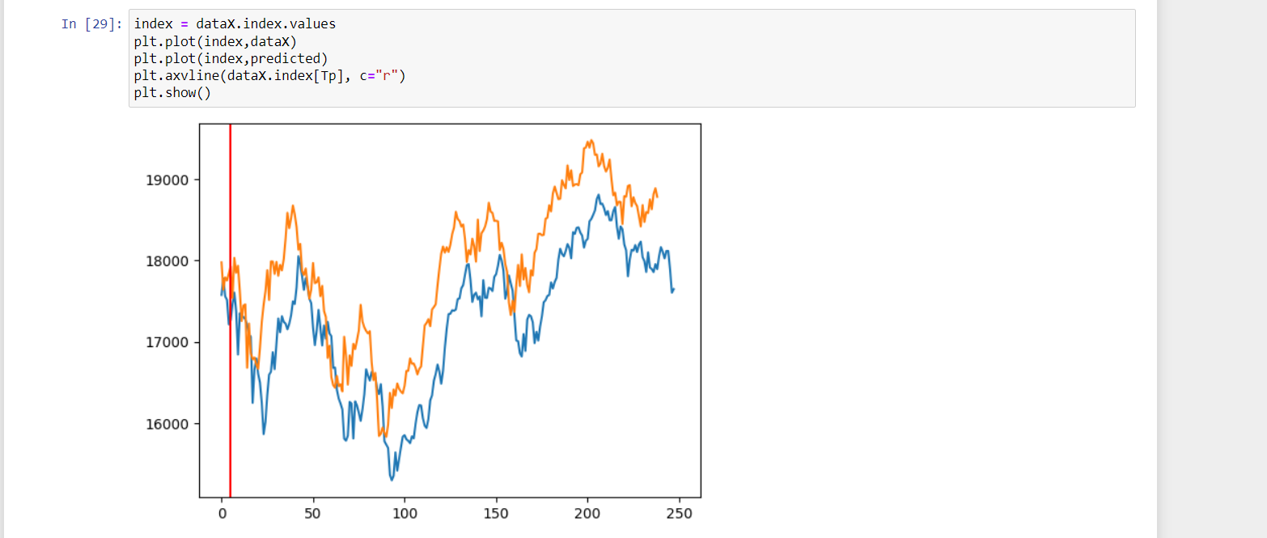

WITH HIDDEN LAYERS:

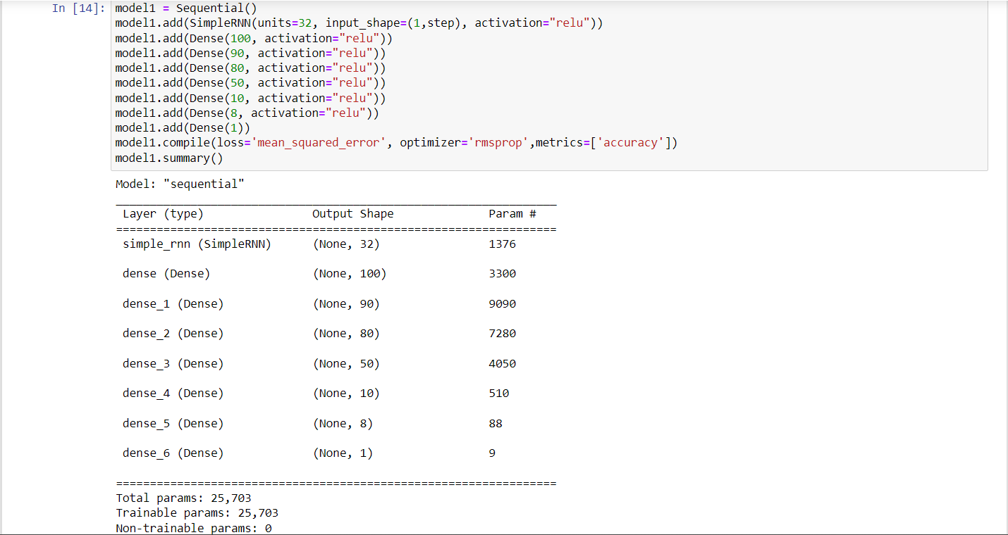

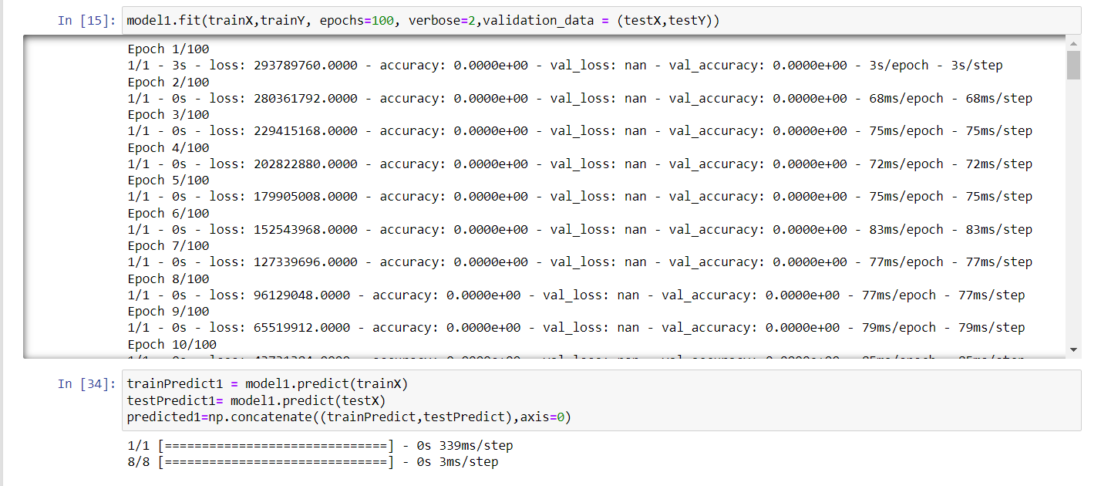 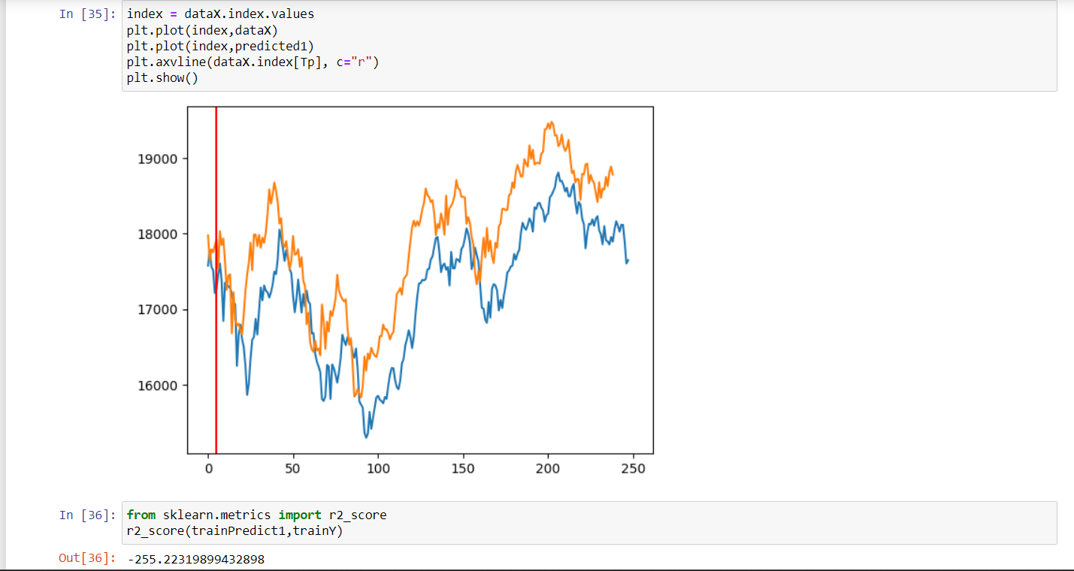

EX.NO:09 NEXT WORD PREDICTION – RNN

DATE: 13.02.23

AIM:

To implement an RNN to predict the next word of a context.

CODE:

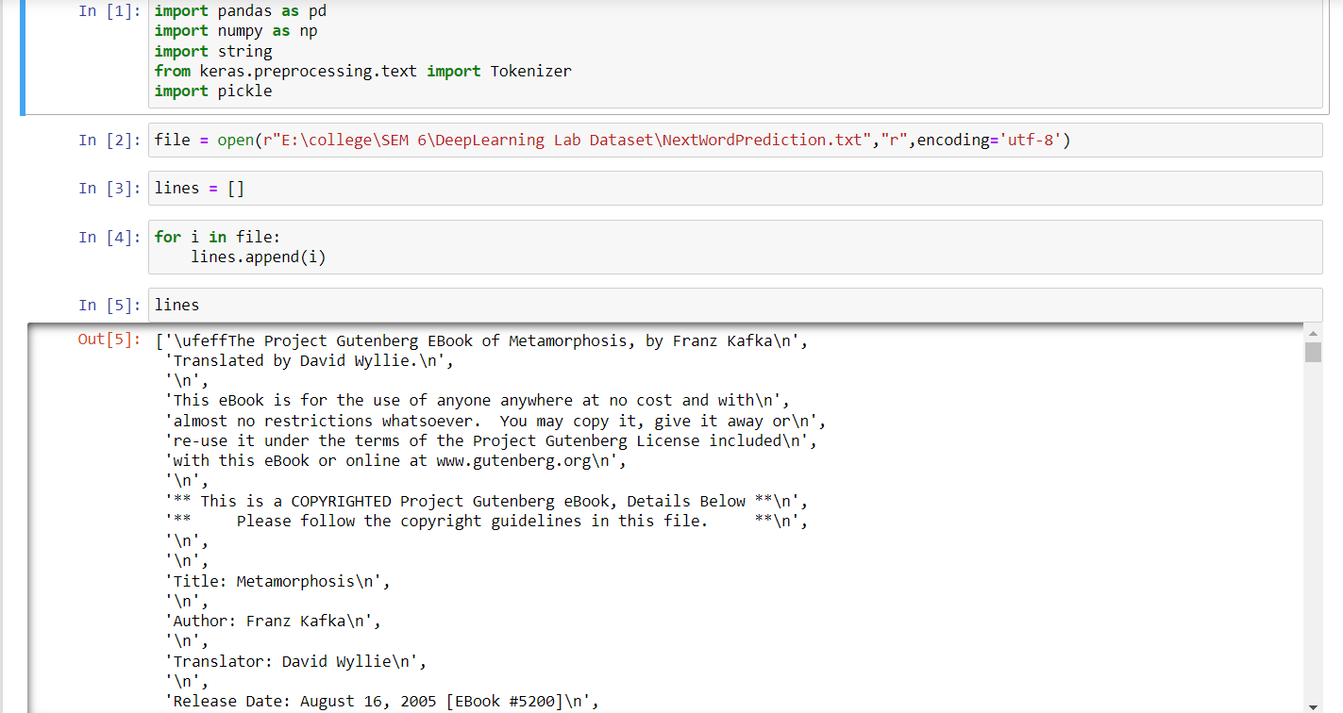    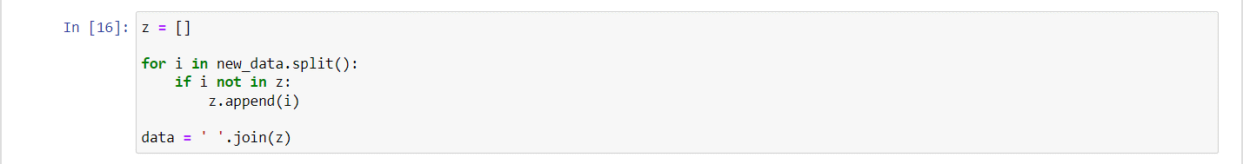 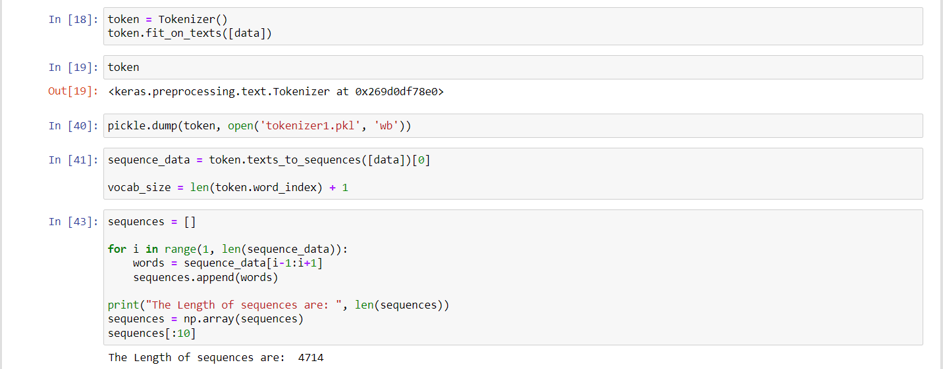

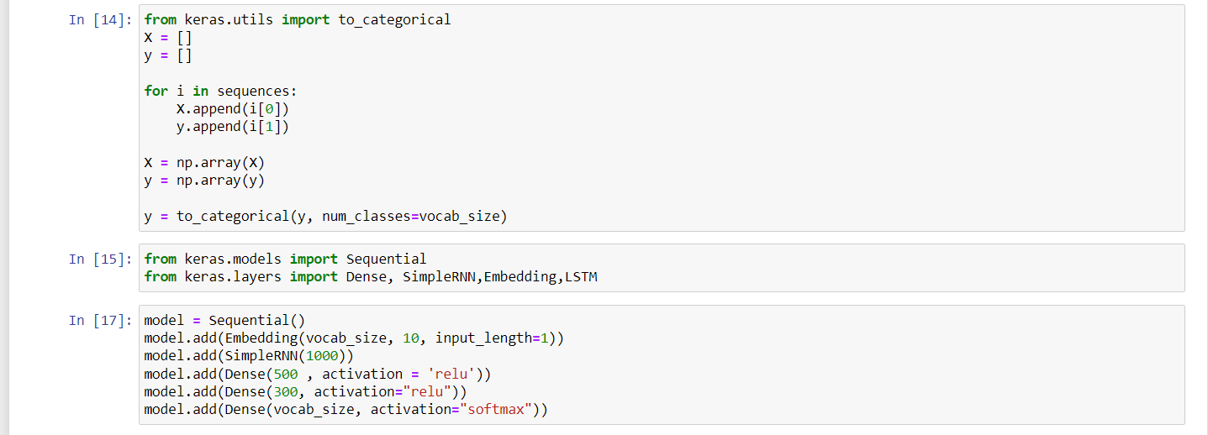 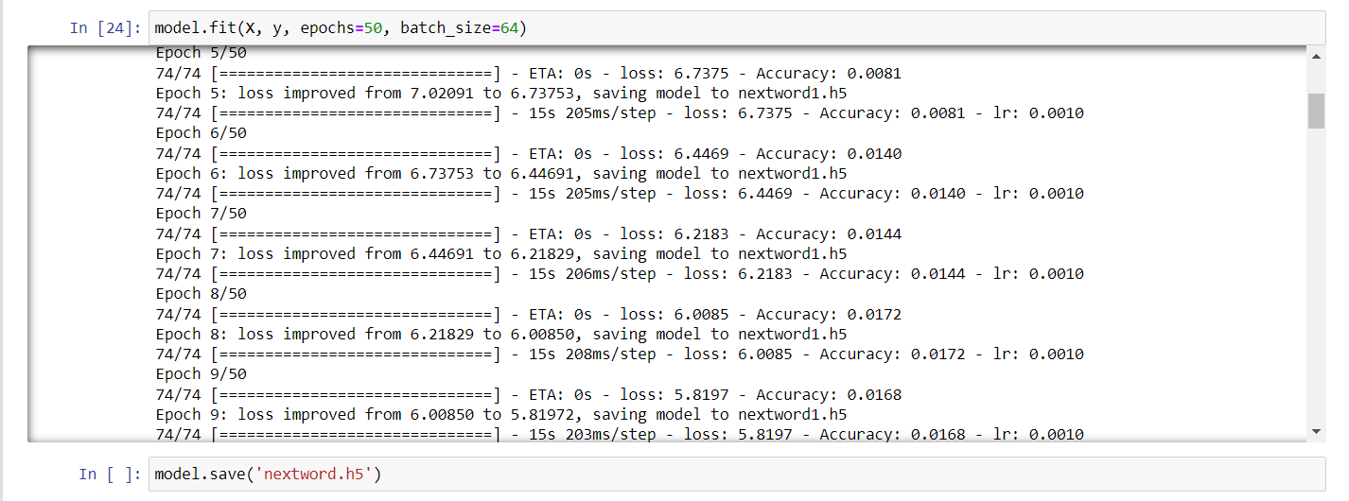 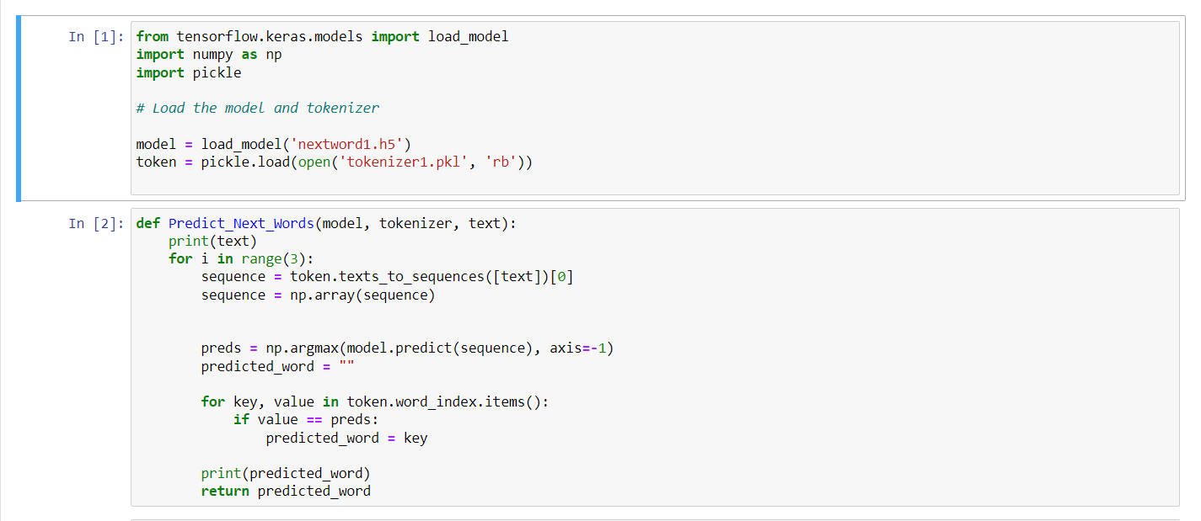 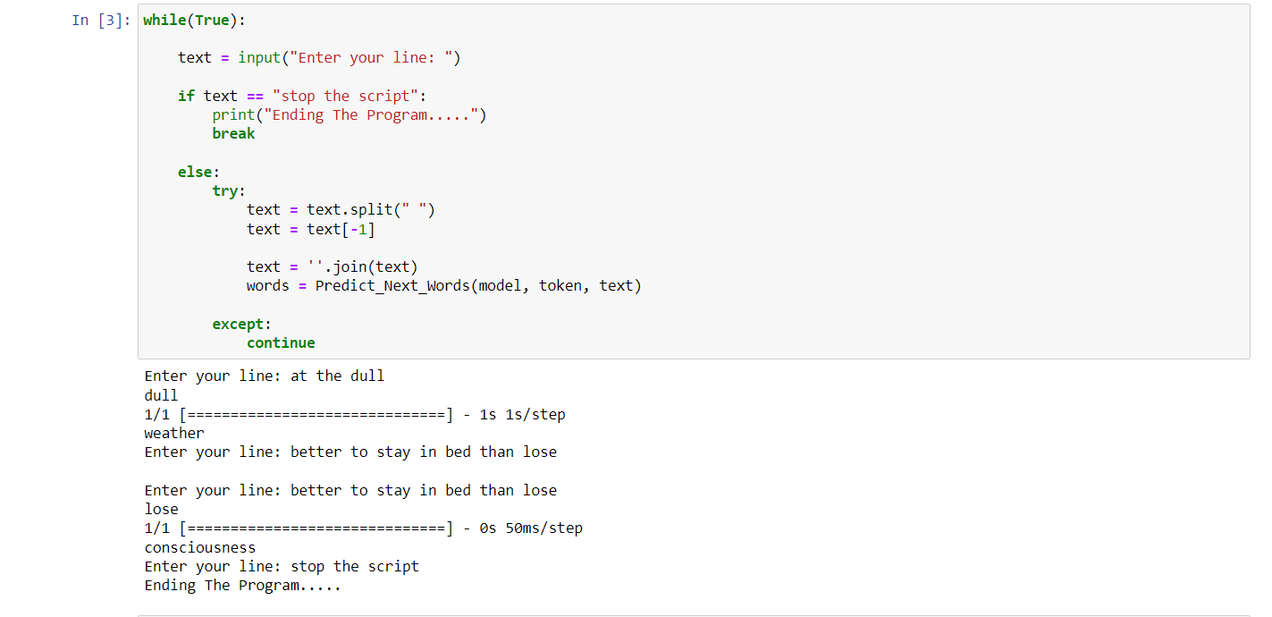

EX.NO:10 NEXT WORD PREDICTION USING LSTM

DATE:13.02.23

AIM:

To implement an LSTM to predict the next word of the given context.

CODE:

     

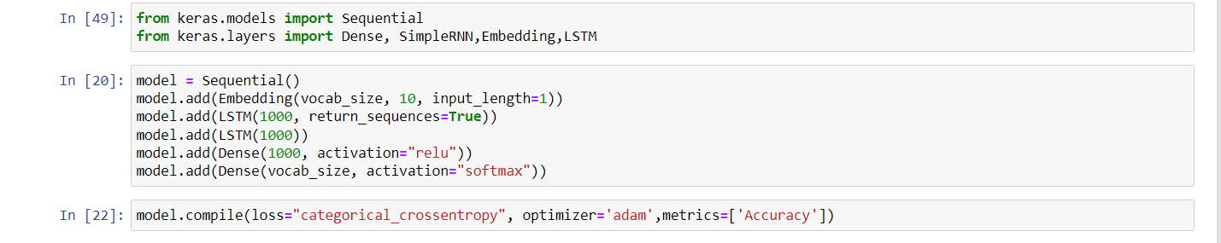 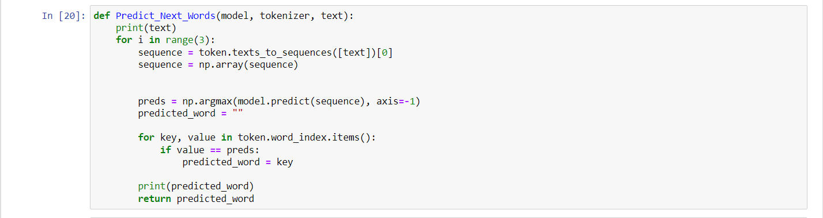 

EX.NO:11 CNN FOR HANDWRITTEN DATA [MNIST]

DATE: 03.03.23

AIM:

To build a CNN model for the MNIST handwritten dataset.

CODE:

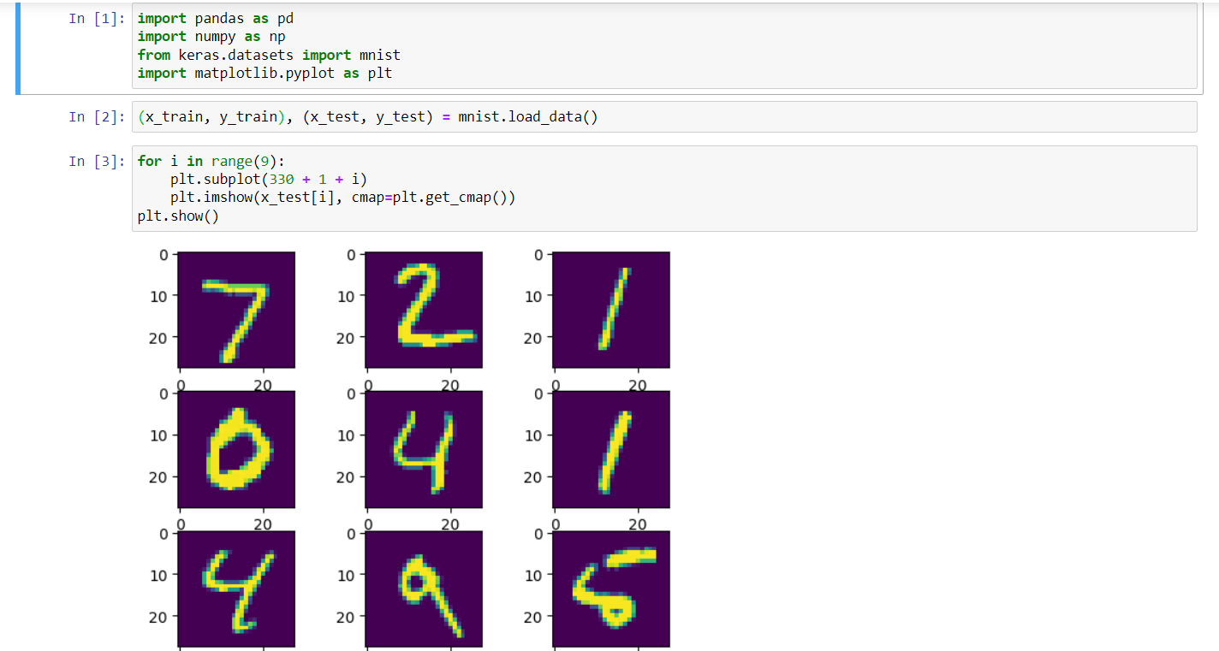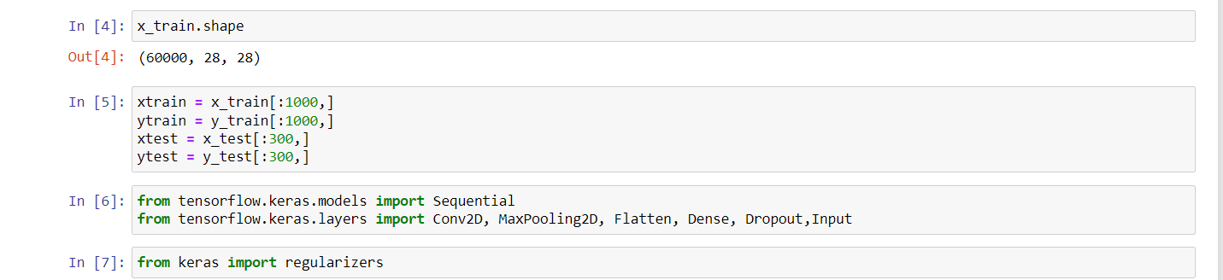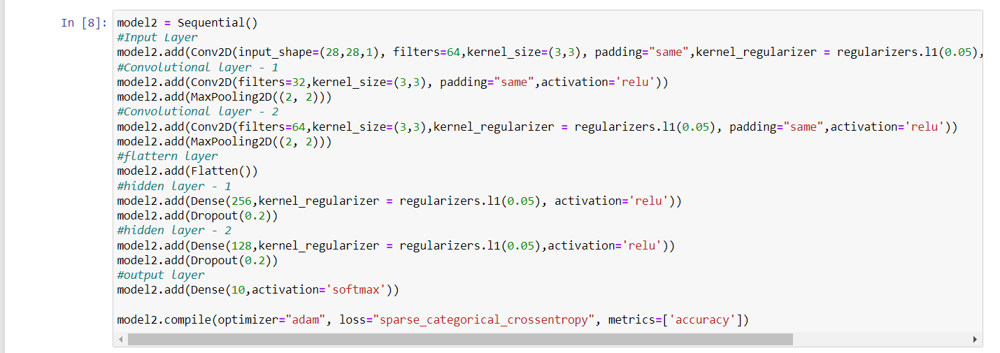

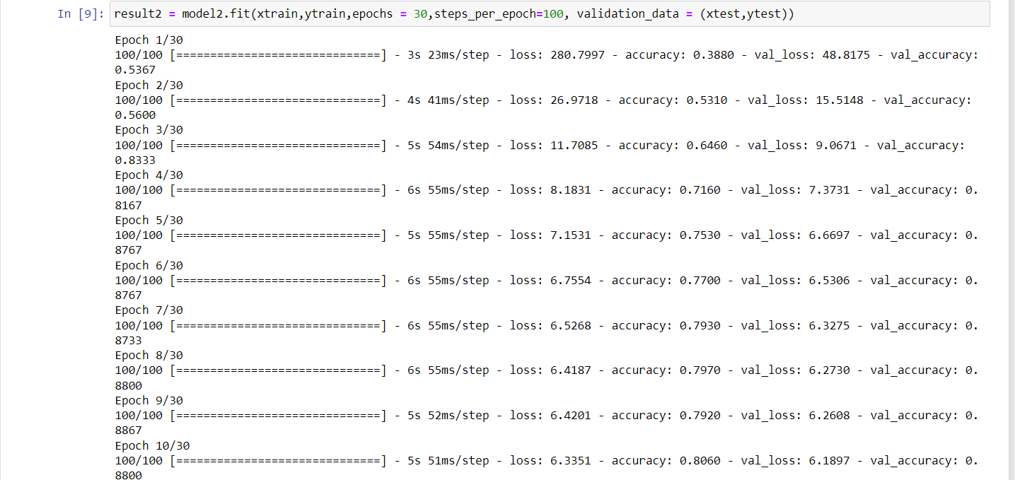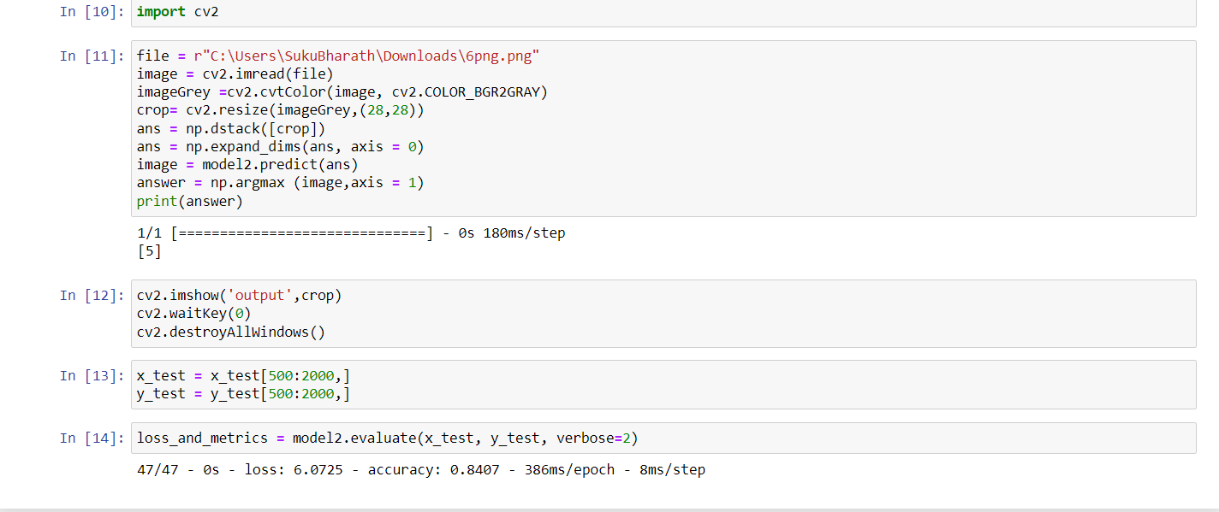

EX.NO:12 LSTM FOR IMDB DATASET

DATE:03.03.23

AIM:

To build the LSTM model to predict the movie reviw based the Comments.

CODE:

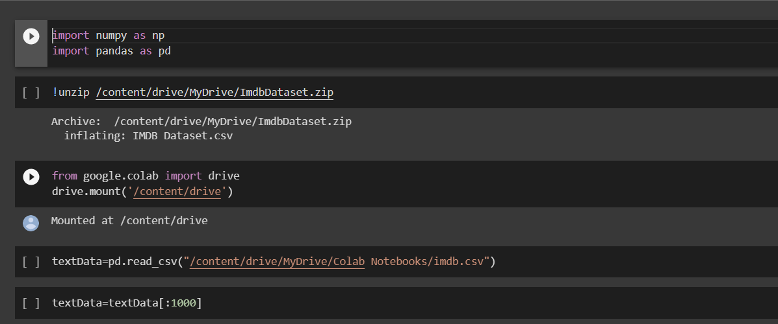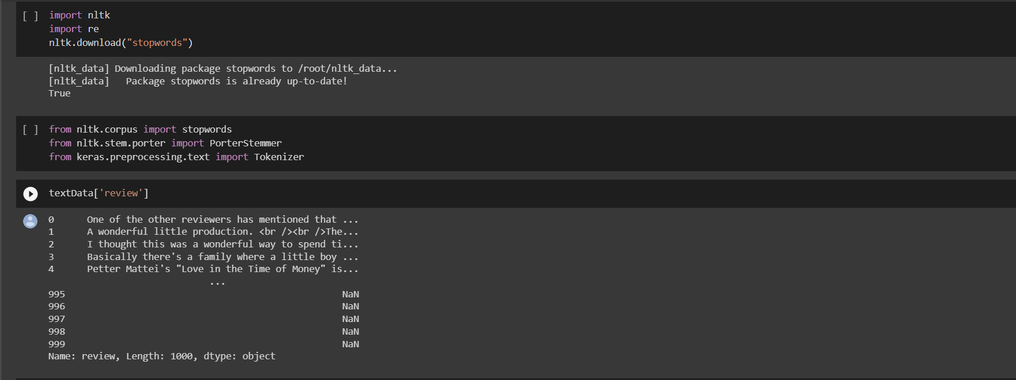

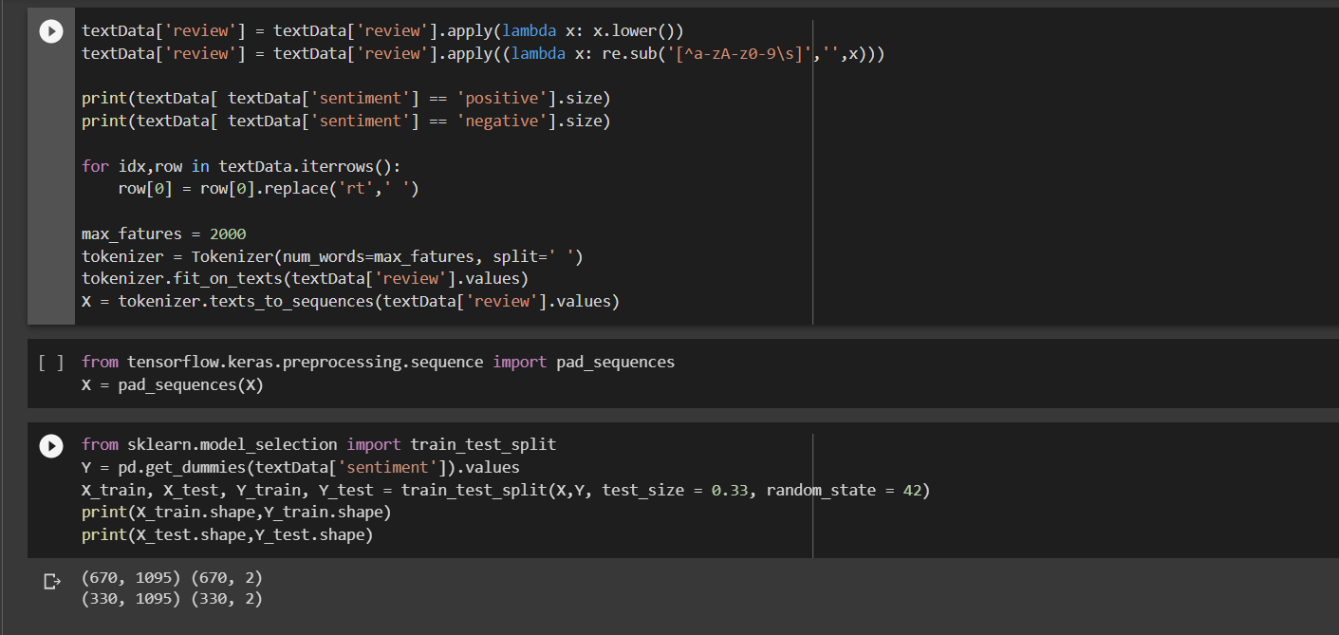

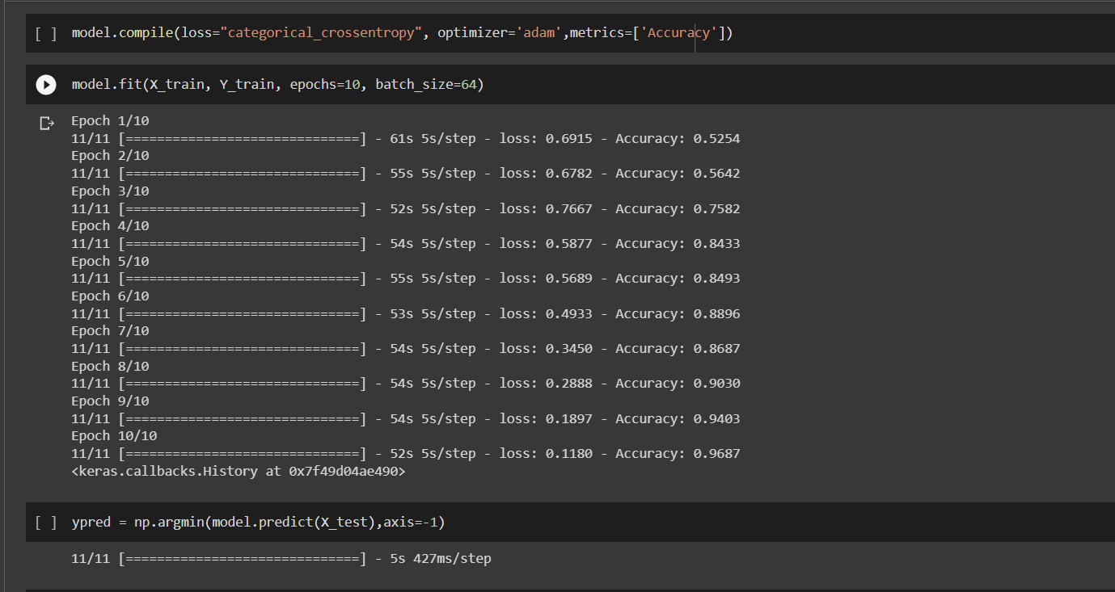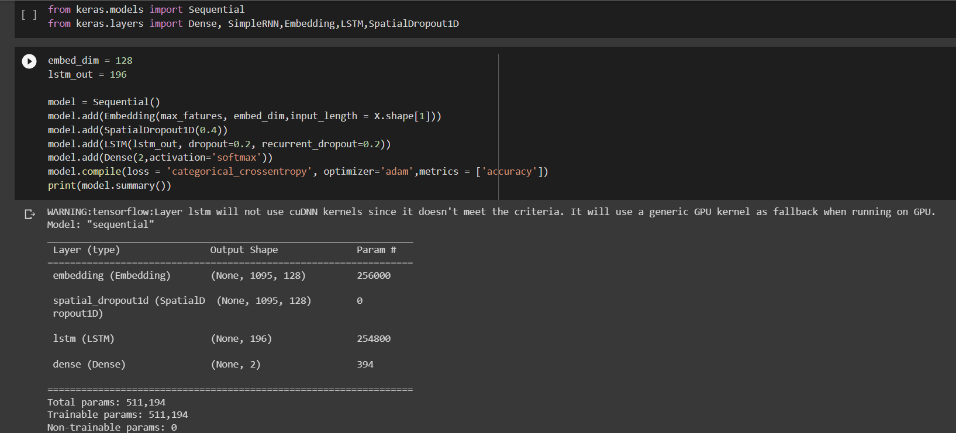

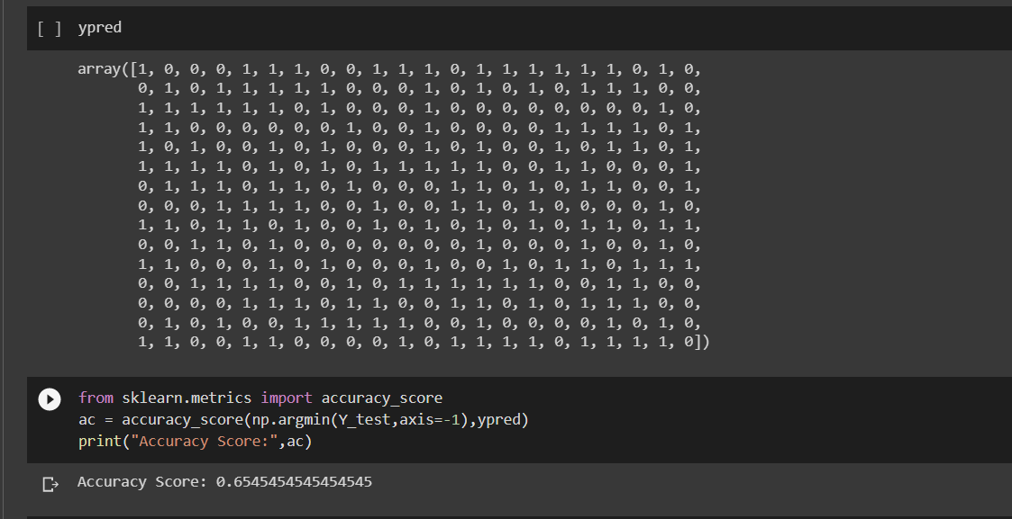

EX.NO:13 **TRANSFER LEARNING,FEATURE EXTRACTION AND FINE TUNING OF VGG-16**

DATE: 06.03.23

AIM:

To Implement feature extraction and fine tuning for VGG-16 model for the photo dataset.

CODE:

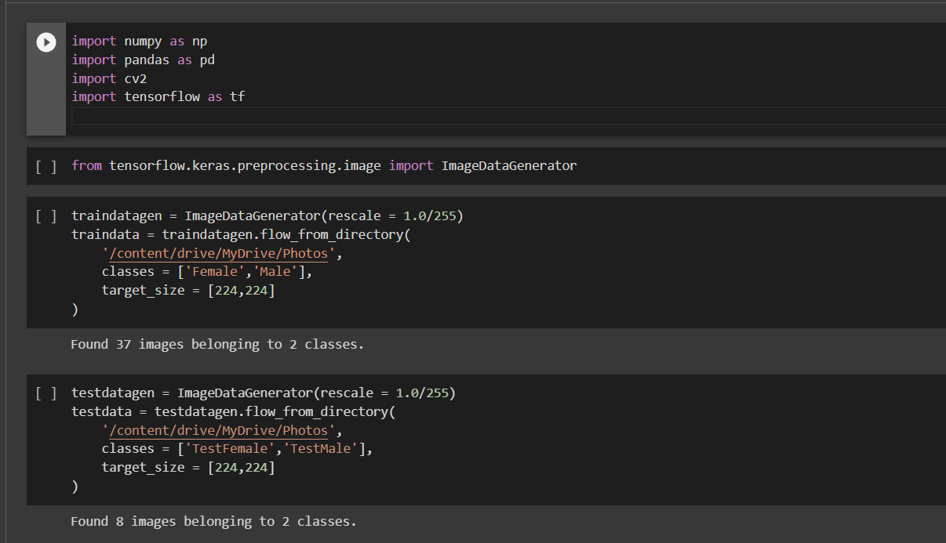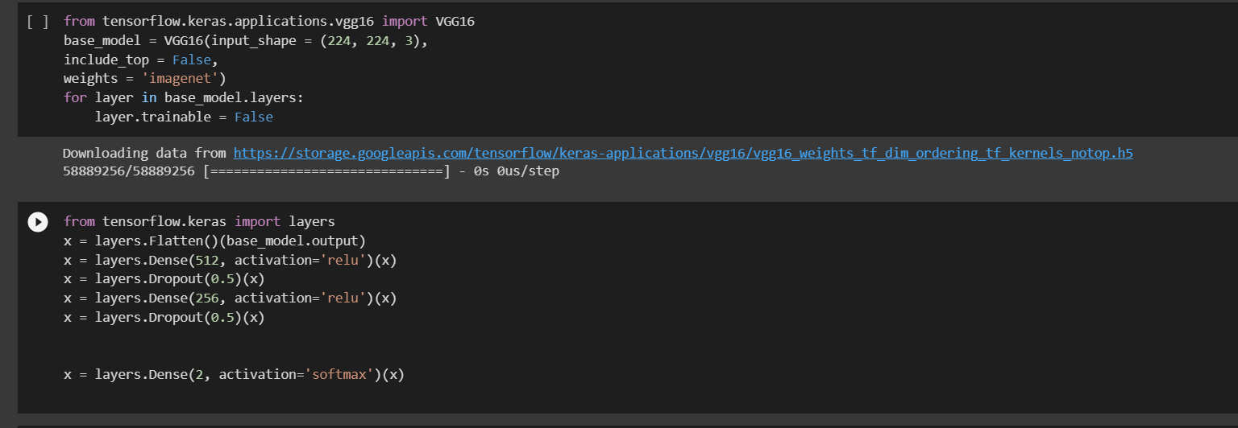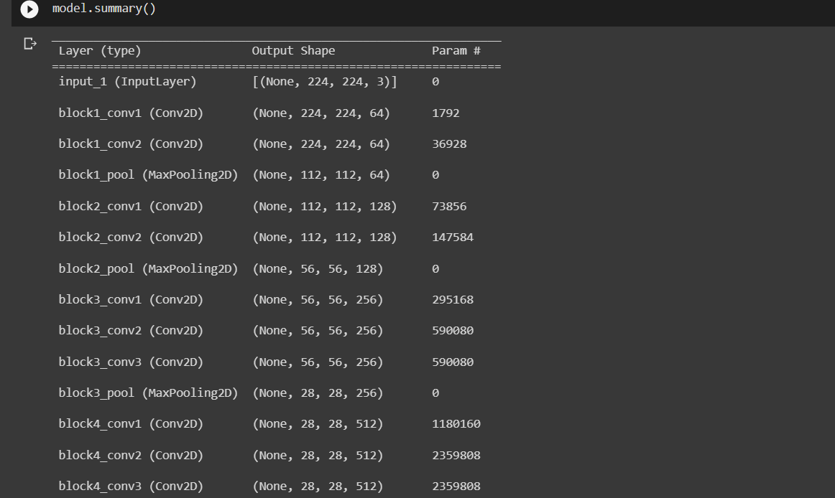

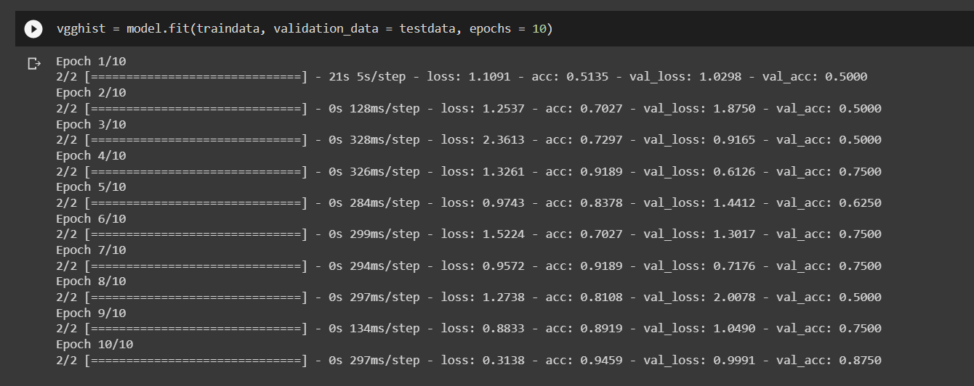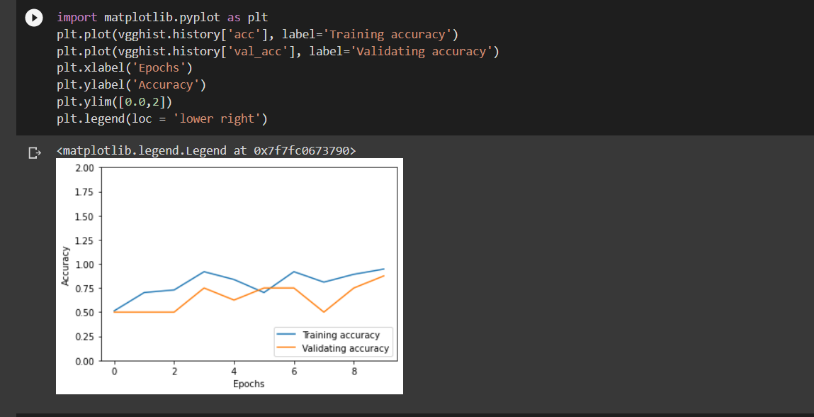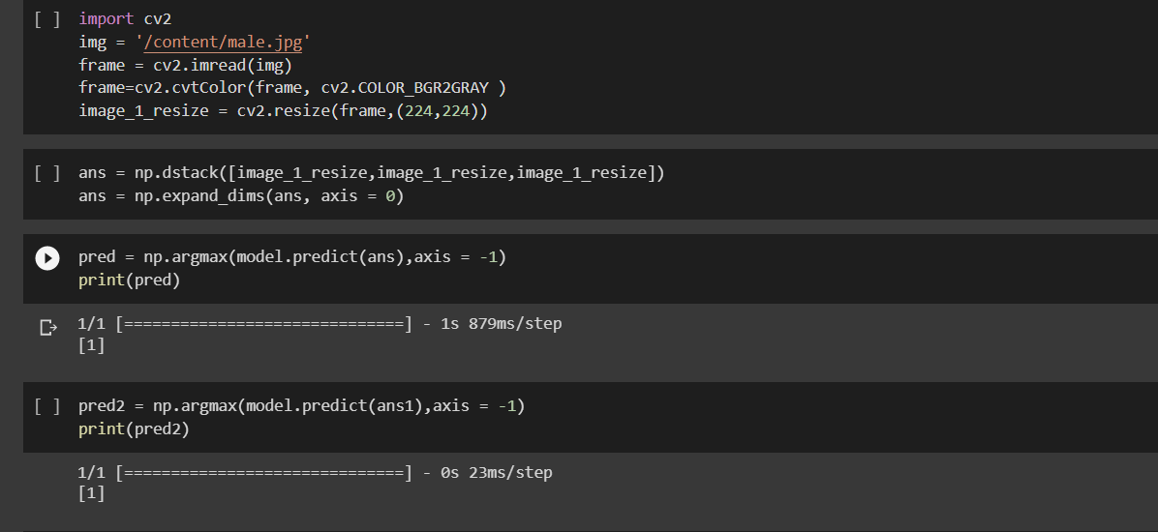

EX.NO:14 BERT MODEL FOR IMDB DATASET

DATE: 17.04.23

AIM:

To build an BERT model to implement sentiment analysis on the IMDB movie review dataset.

CODE:

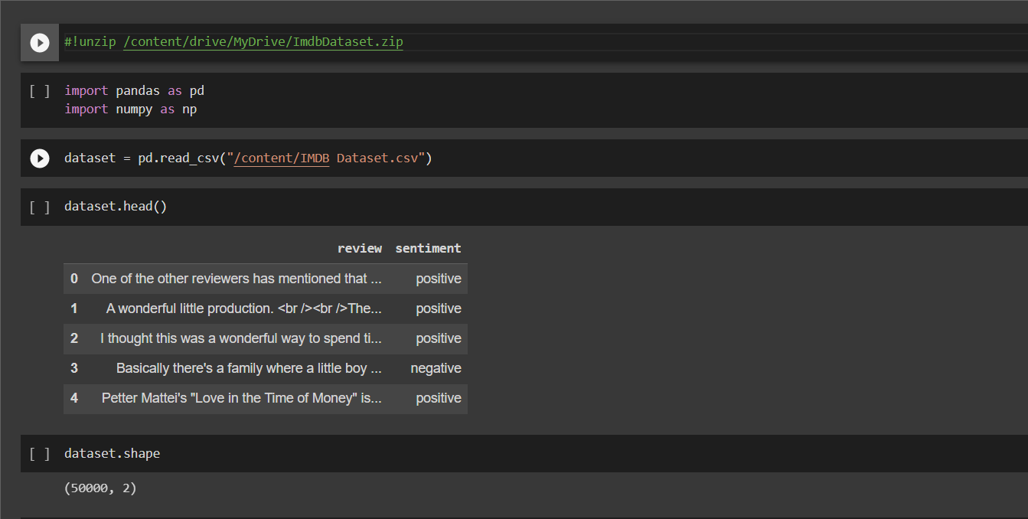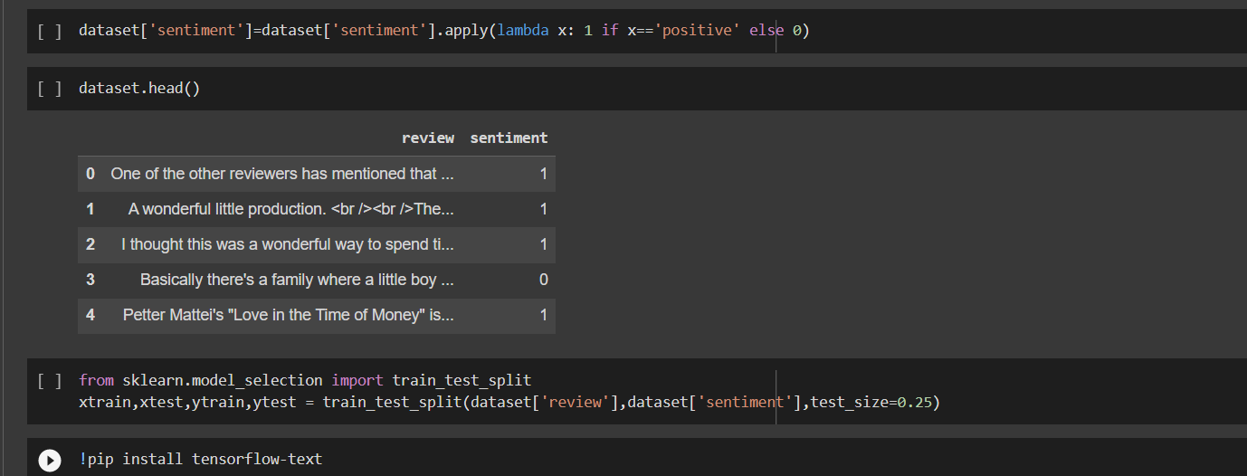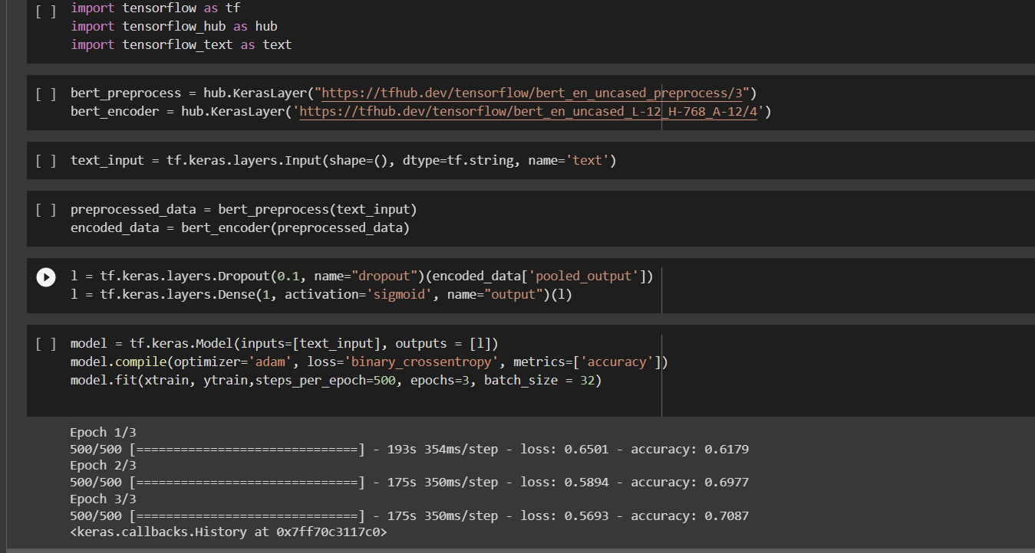

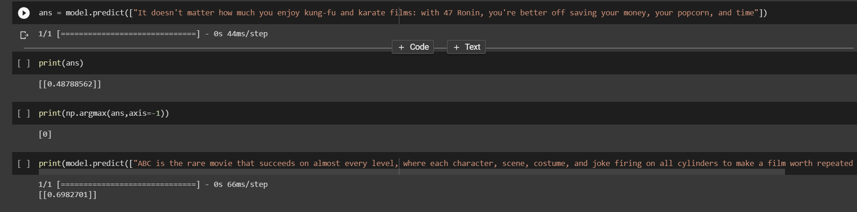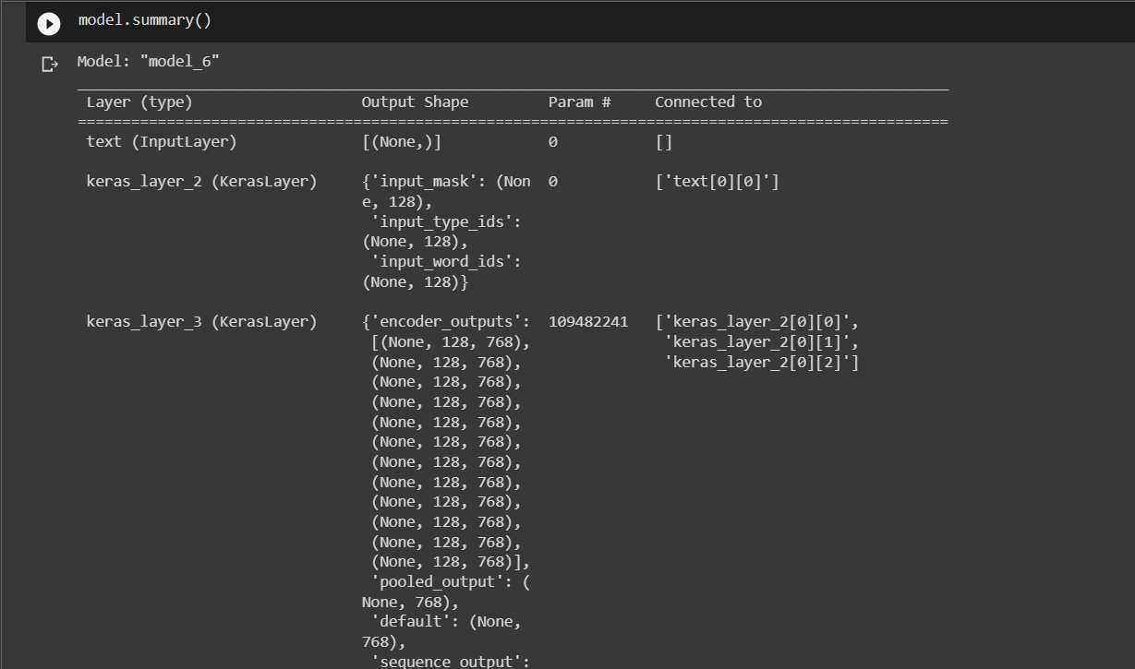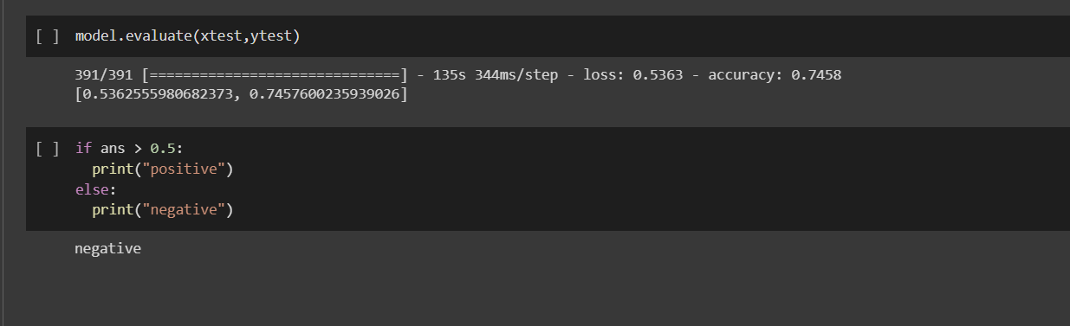

EX.NO:15 GANS FOR MNIST DATA

DATE:10/04/23

AIM:

To construct a GAN for generationg new images from fashion-MNIST Data.

CODE:

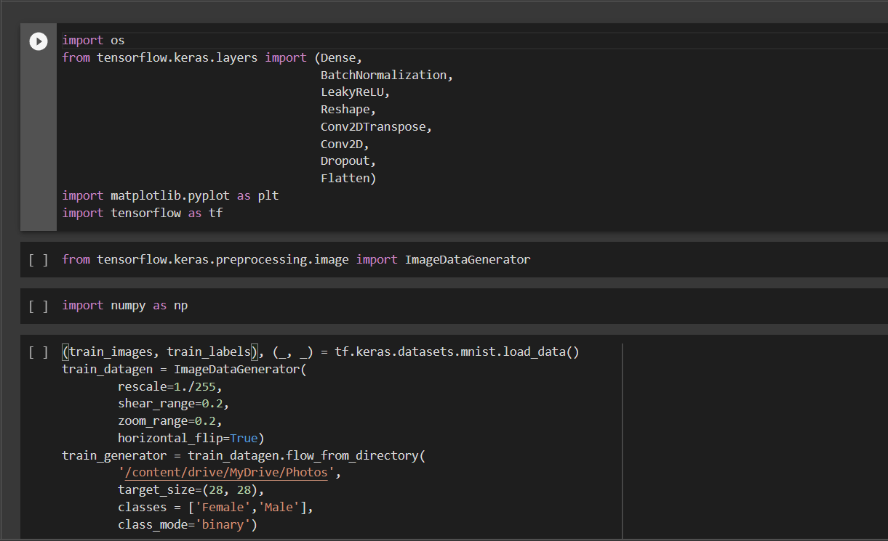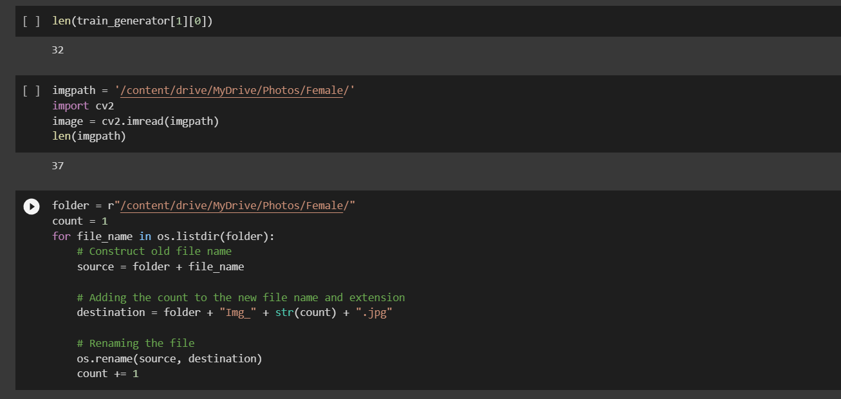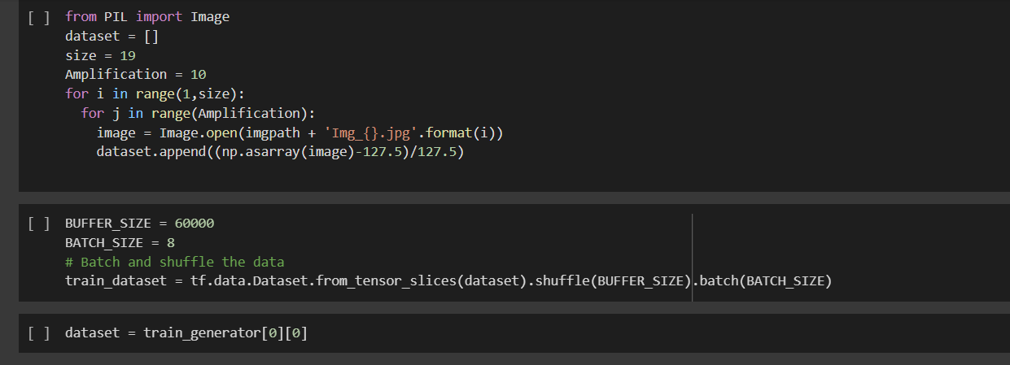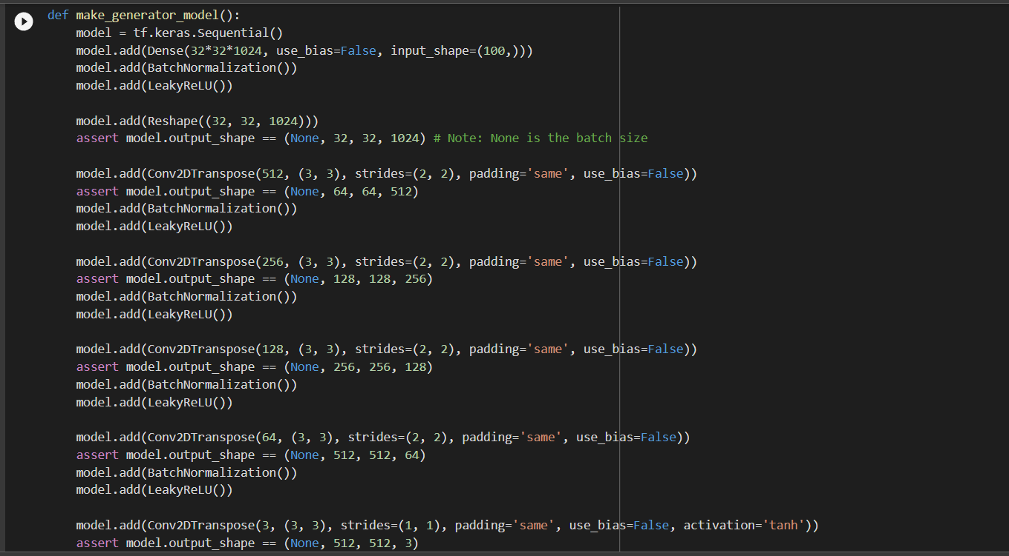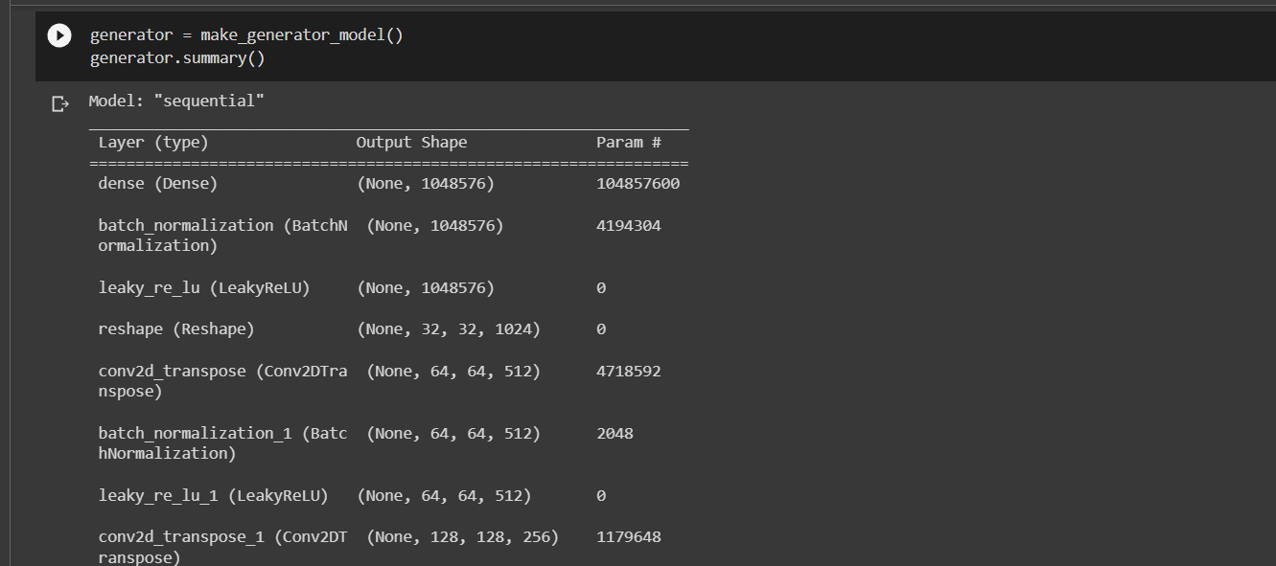

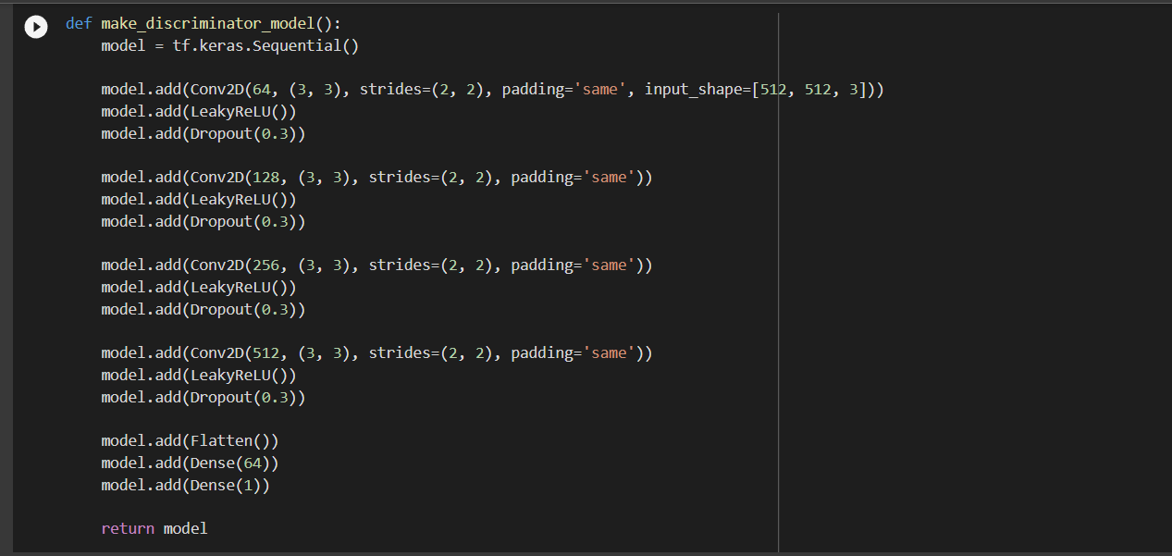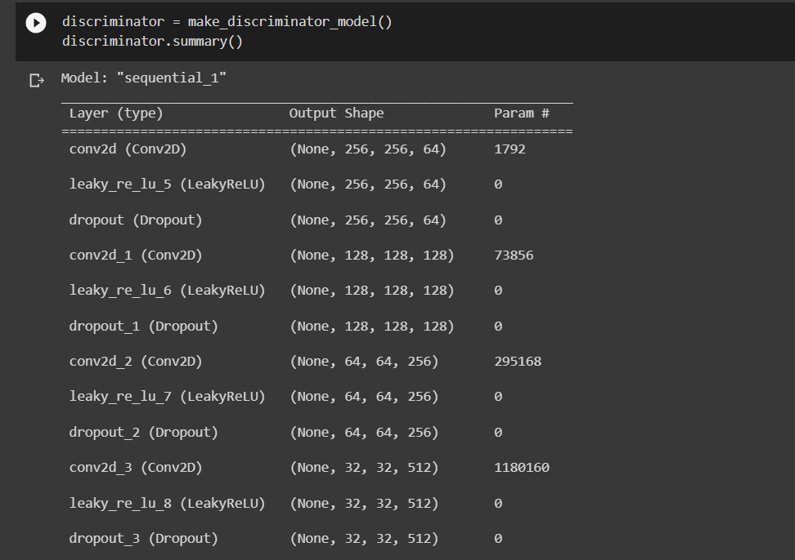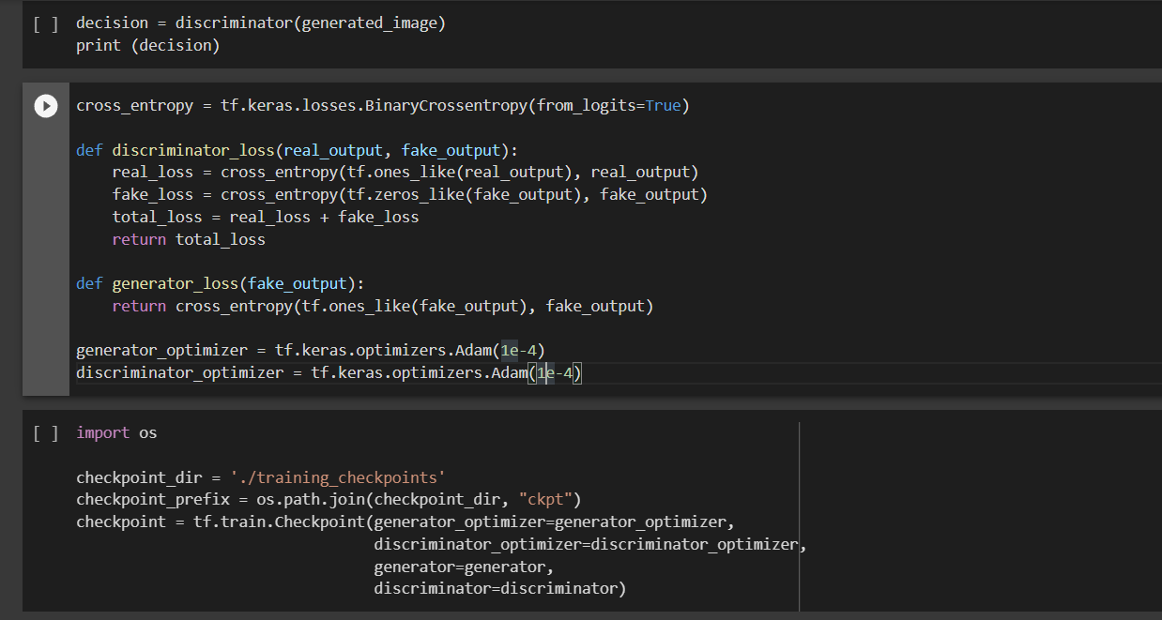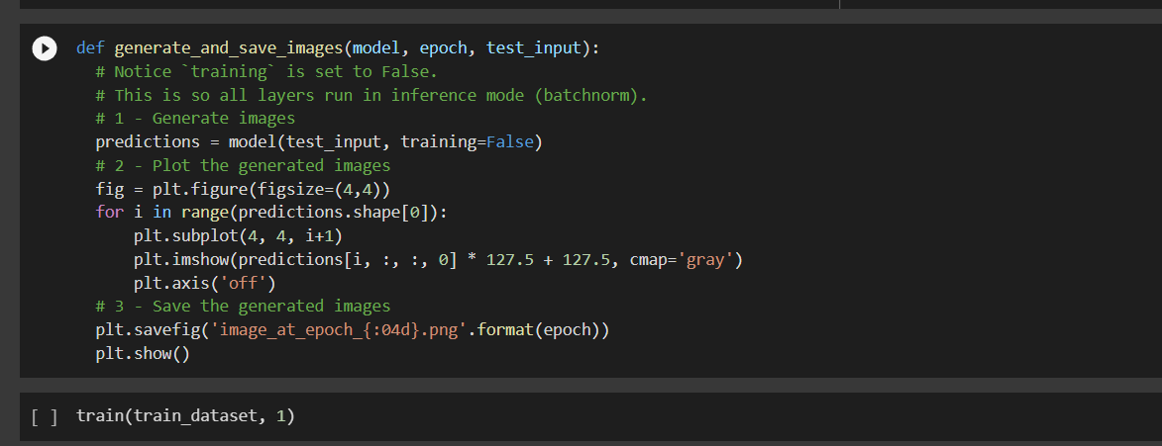

**PROJECT**

**PCOS DETECTION**

PROBLEM STATEMENT: **PCOS DETECTION**

**AIM:**

To develop a disease diagnostics for PCOS by classifying images as either depicting individuals diagnosed with polycystic ovary syndrome or not.

**DATASET DESCRIPTION:**

 The ultrasound photos that showed infected cysts on the ovary were given the label ‘infected’ while the ultrasound images that showed a healthy ovary were given the label ‘not infected’.

**DATA PREPROCESSING:**

ImageDataGenerator class from the Keras library to perform various preprocessing techniques like rescaling, shear transform, zoom, flip, rotate and fill mode on image data.

**MODEL USED**: InceptionV3, DenseNet and MobileNet

**CODE**

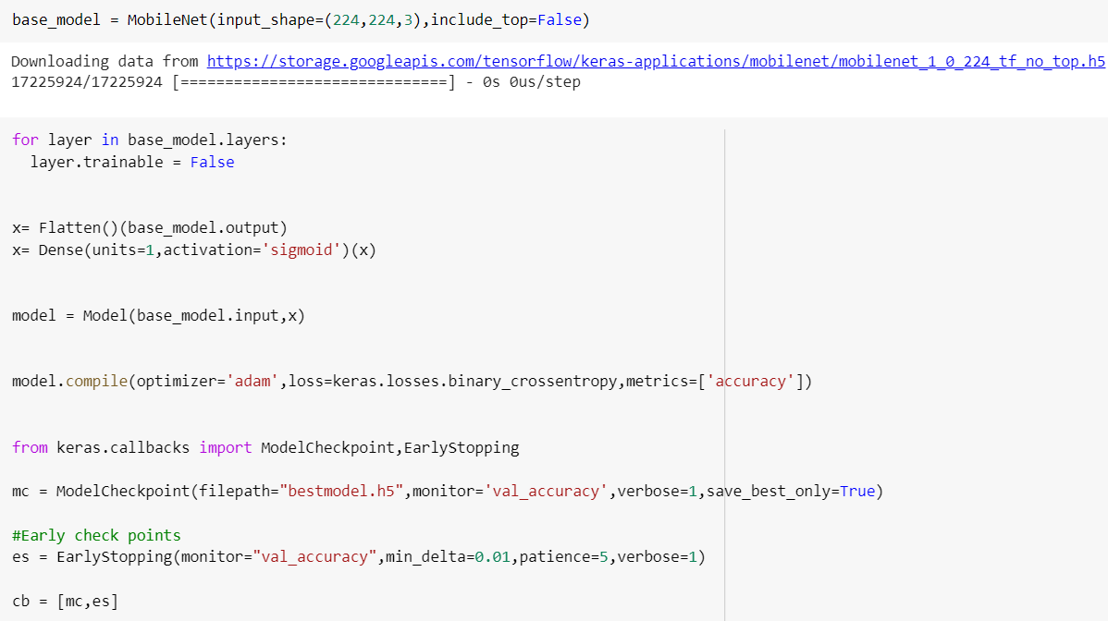

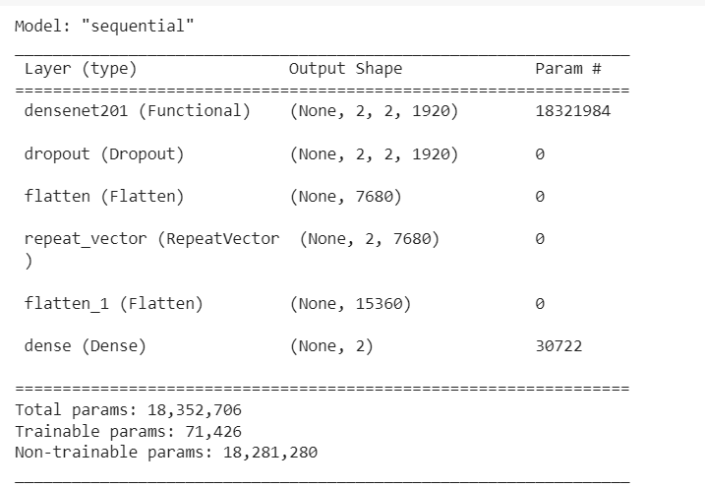

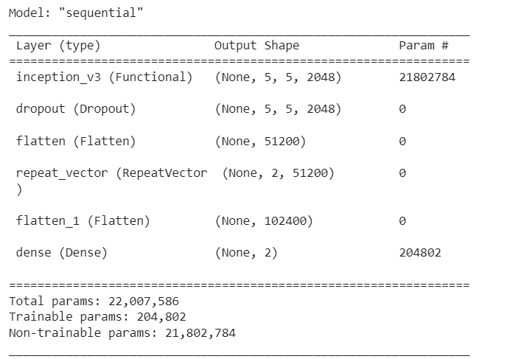

**OUTPUT:**

